/*****************************************************************************

* ITE5315 – Assignment 4

* I declare that this assignment is my own work in accordance with Humber Academic Policy.

* No part of this assignment has been copied manually or electronically from any other source

* (including web sites) or distributed to other students.

* * Name: Yash Ashokkumar Patel Student ID: N01537676 Date: 26/11/2023

*****************************************************************************/

**Assignment-4**

**Name :-** Yash Ashokkumar Patel

**ID :-** N01537676

**Subject :-** Web Programming and Framework 1

**Question 1 :-**

**Step 1 :-**

Created new Node/Express app

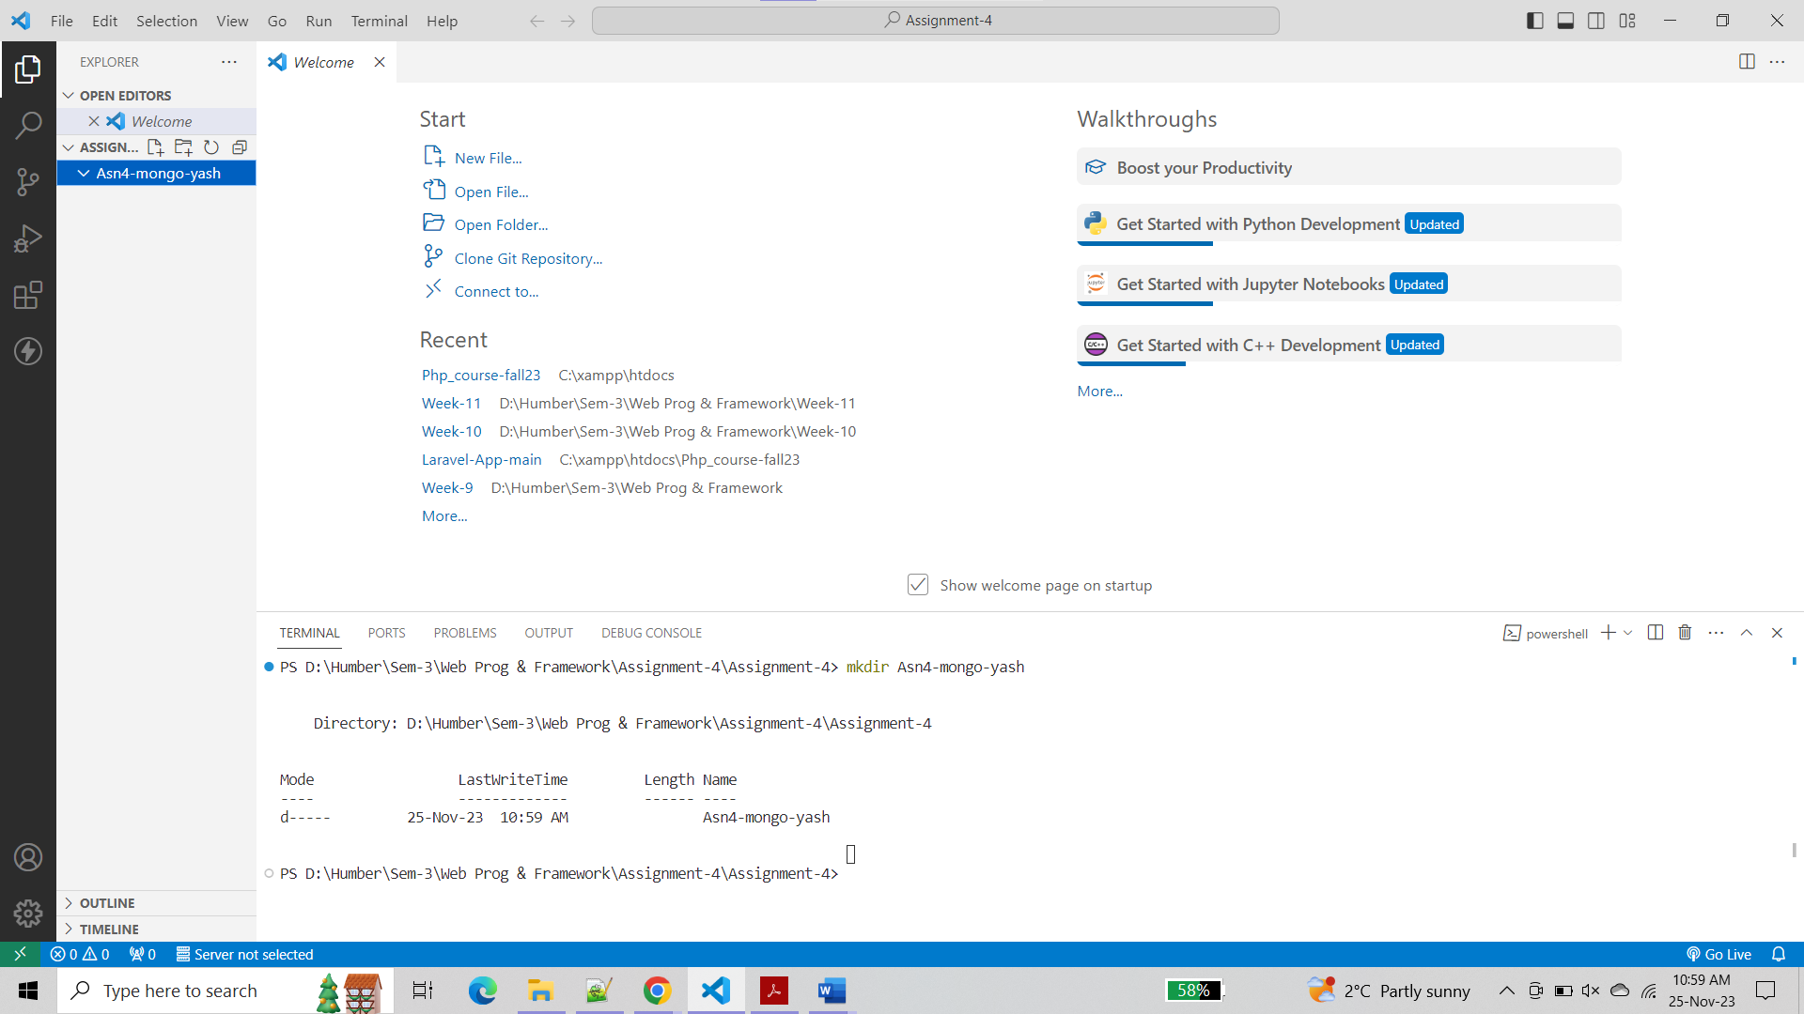

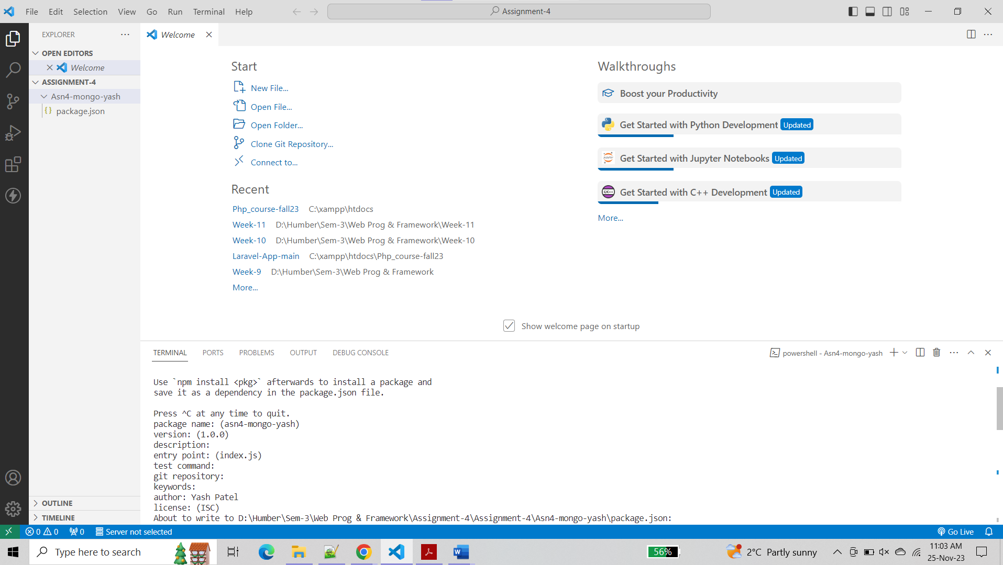

Added the following dependencies to the project

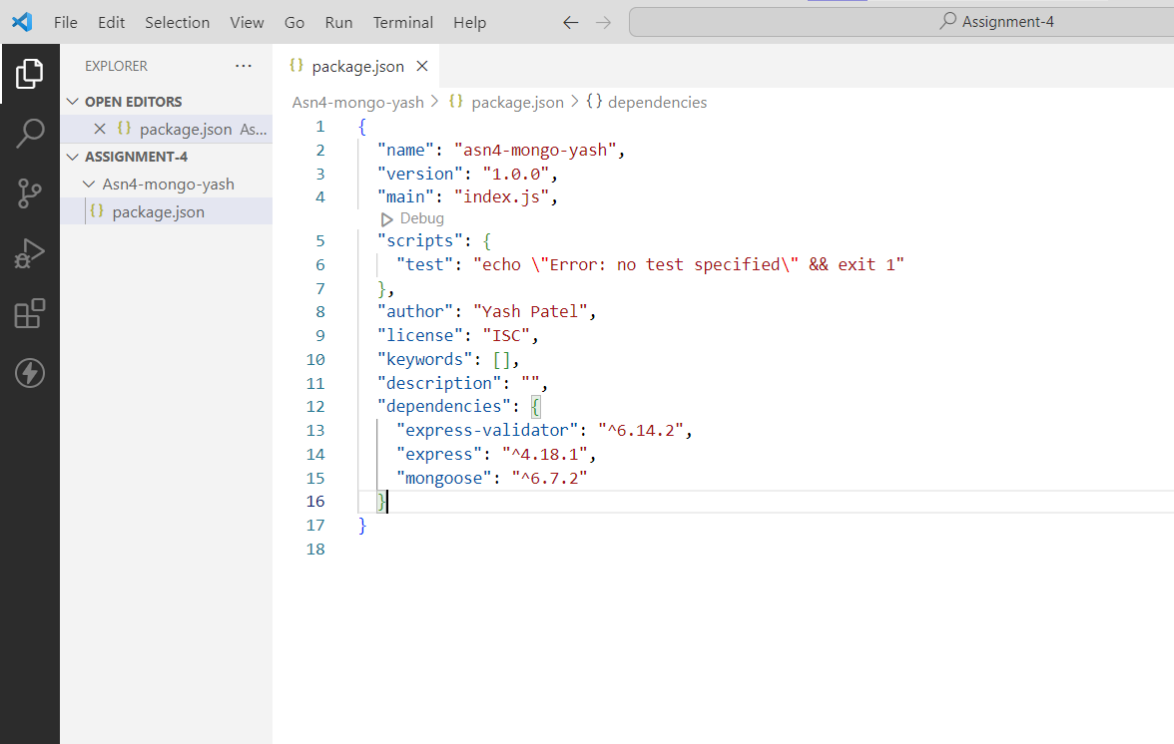

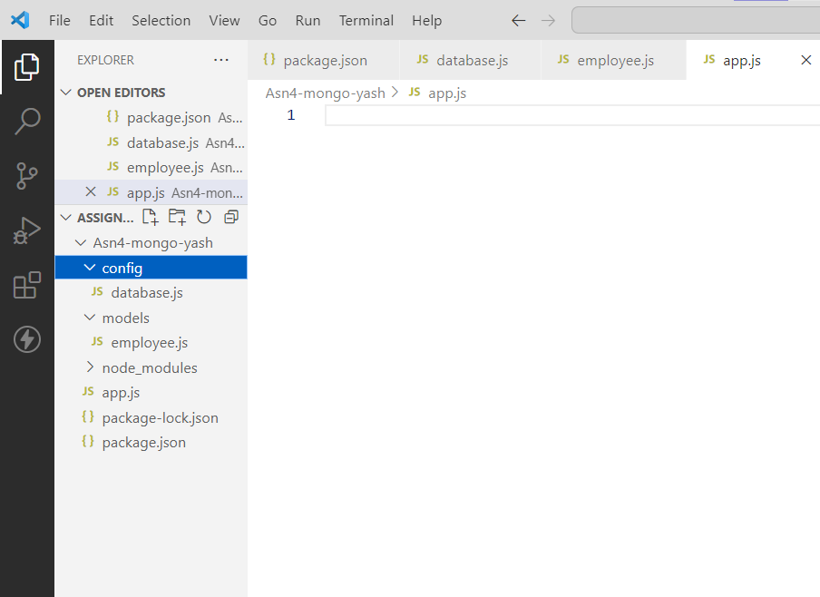

**Step 2 :-**

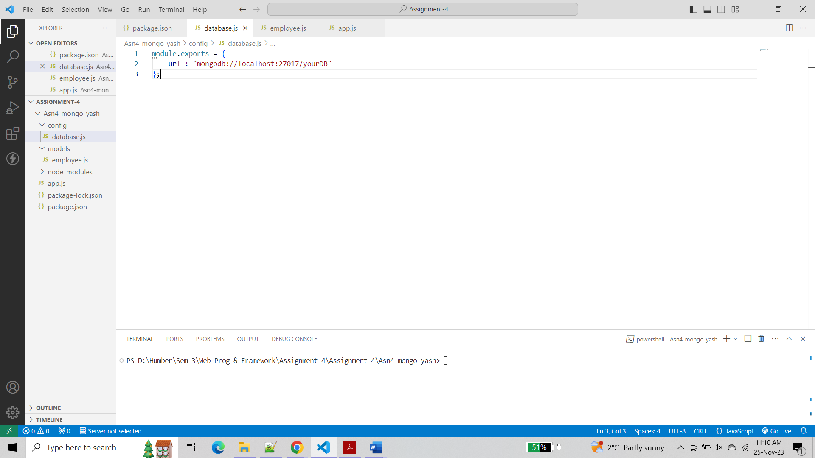

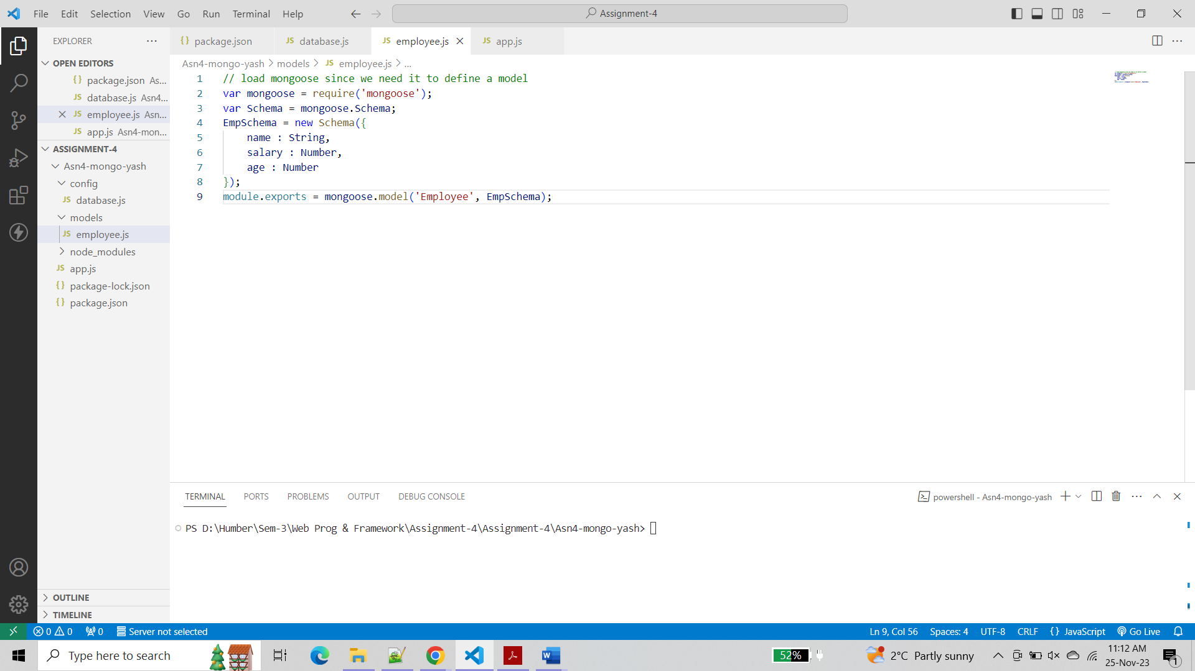

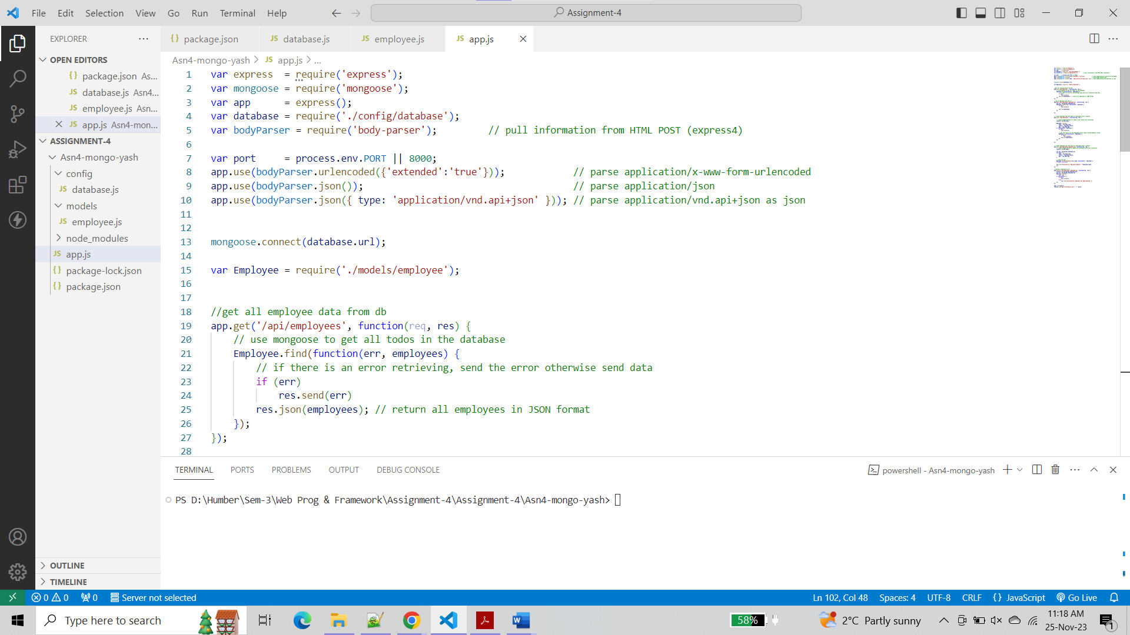

**Step 3 :-**

1. Open Postman, choose POST method and use the url <http://localhost:8000/api/employees>

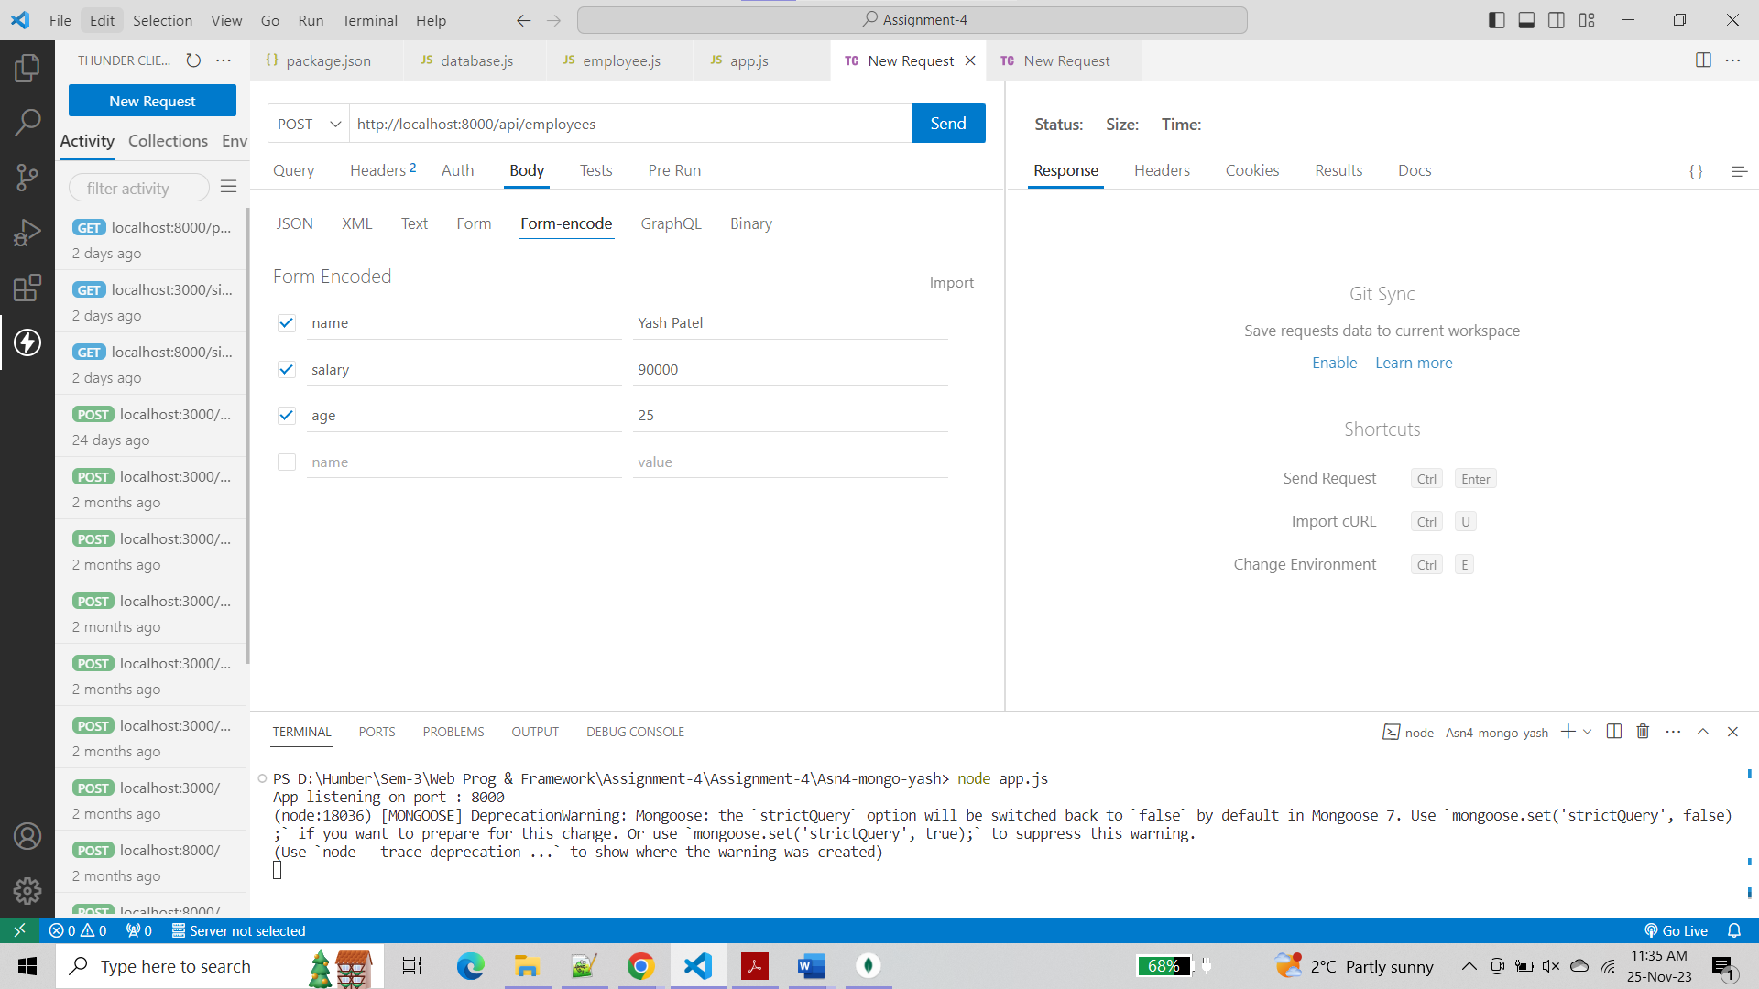

* Click on send. What is the output?

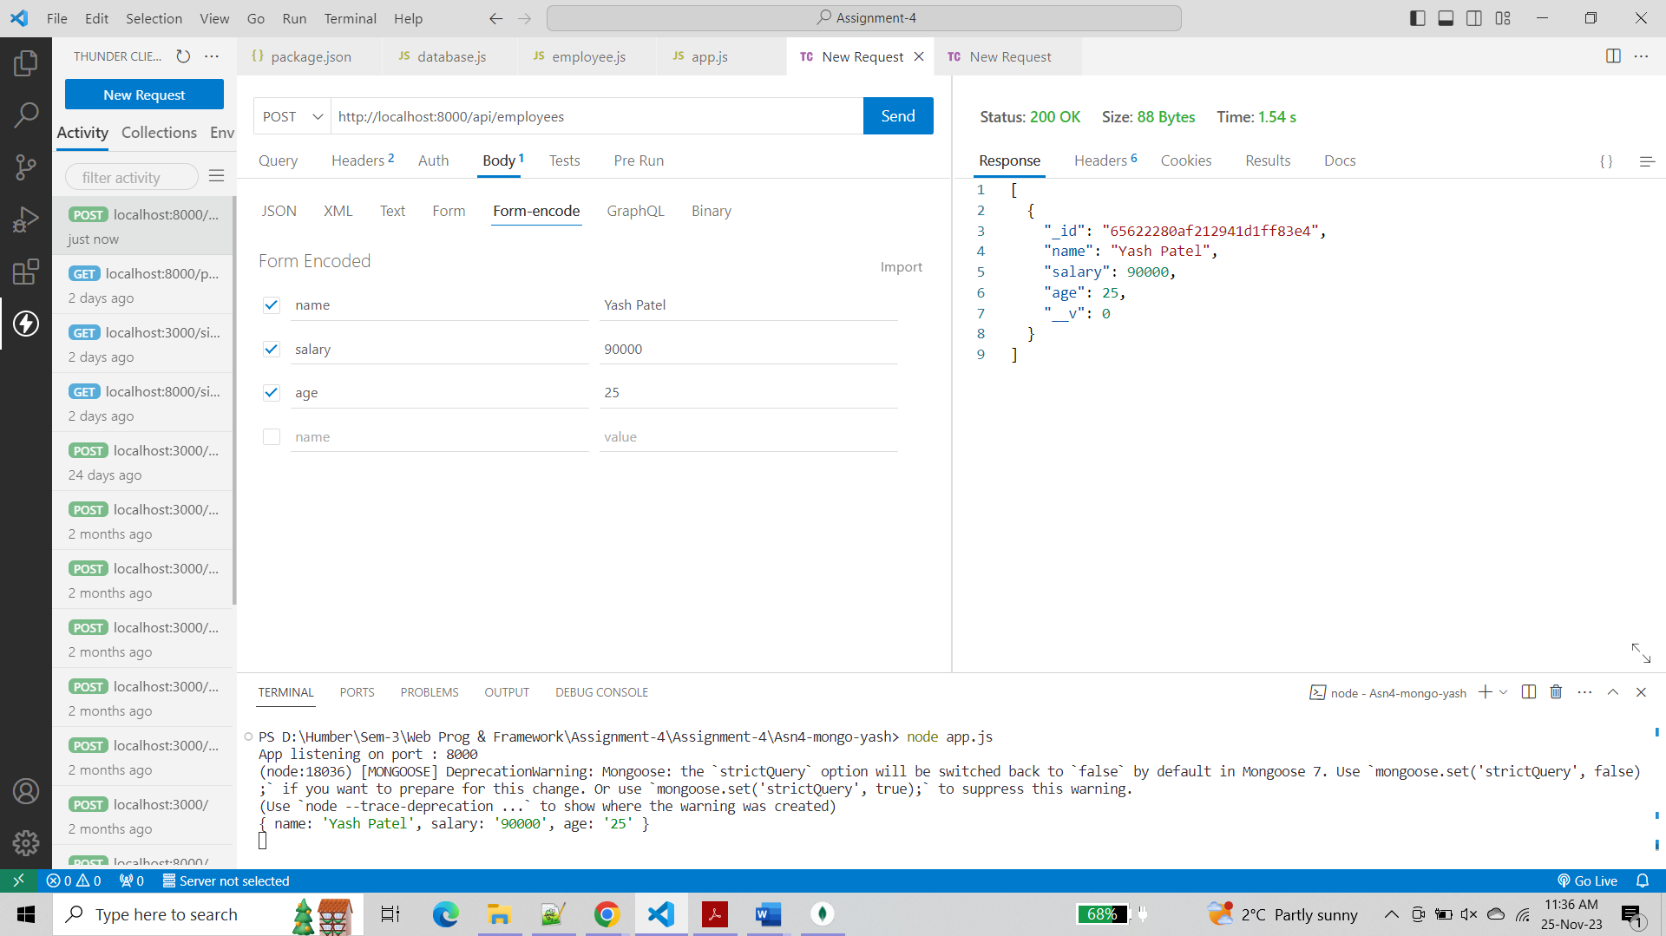

* Check the console in VScode, what is the output?

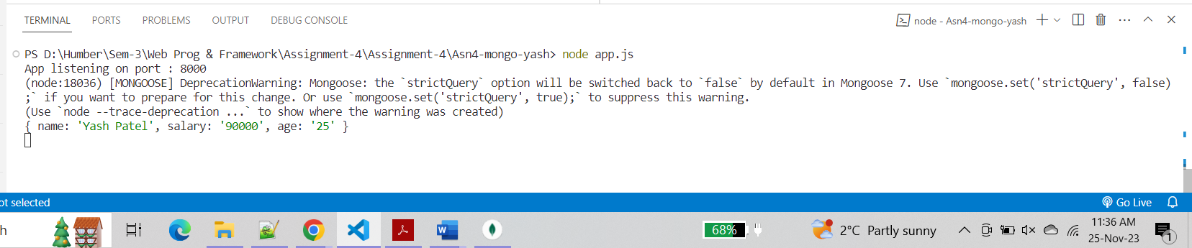

* Check the Compass, is the new record added to “Employee” collection in Database?

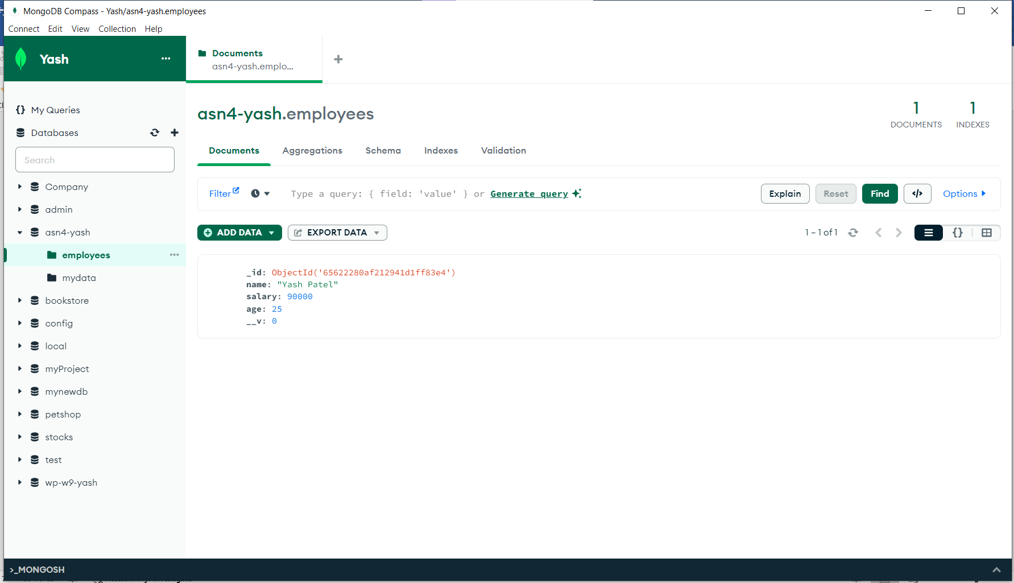

1. Open browser and enter <http://localhost:8000/api/employees>

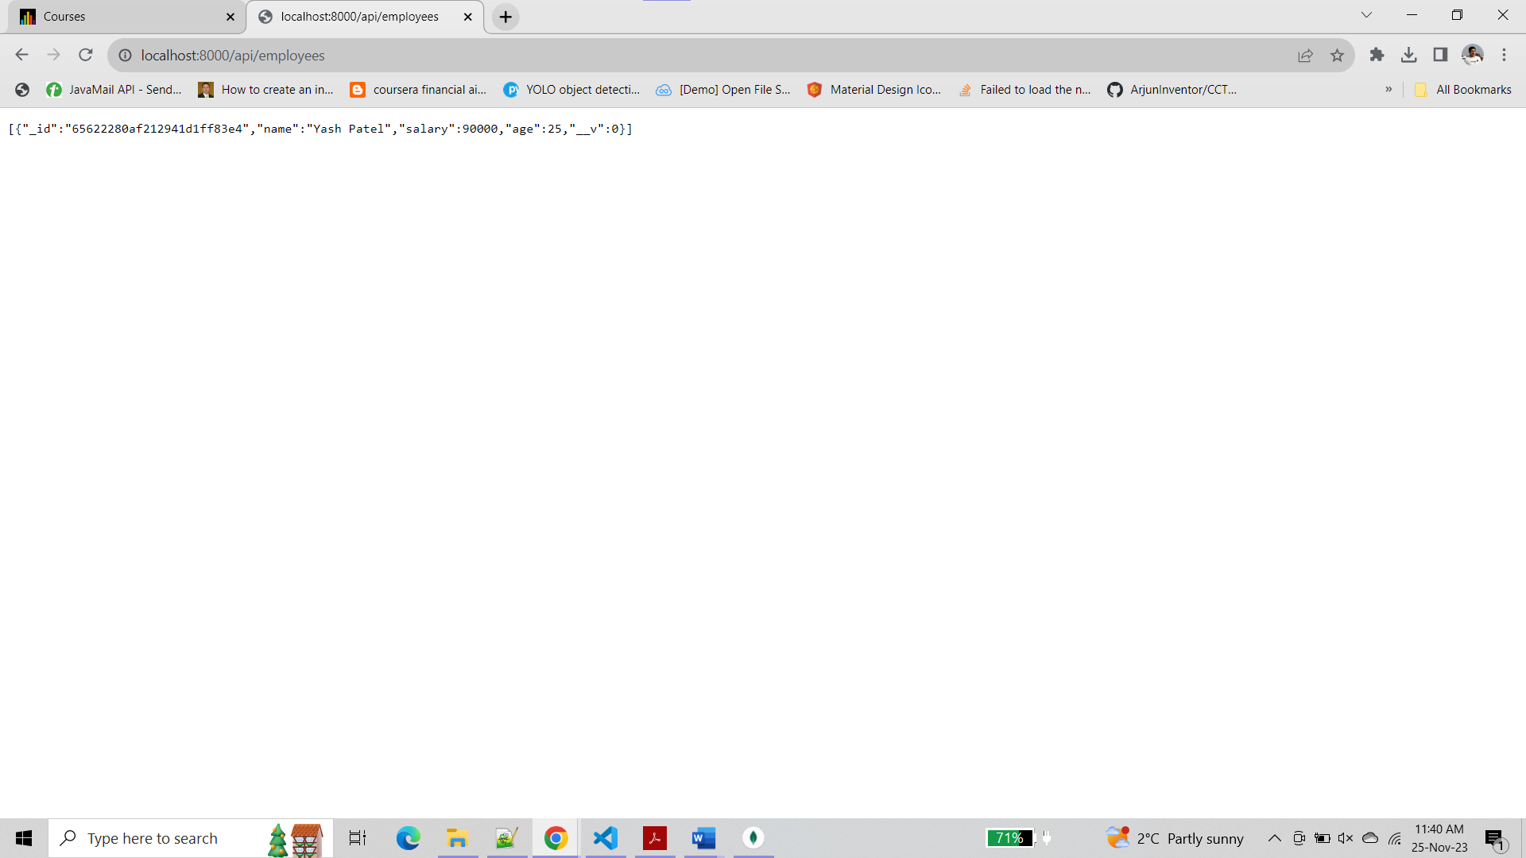

1. Using any _id of any employee records in database, run the following query in the browser

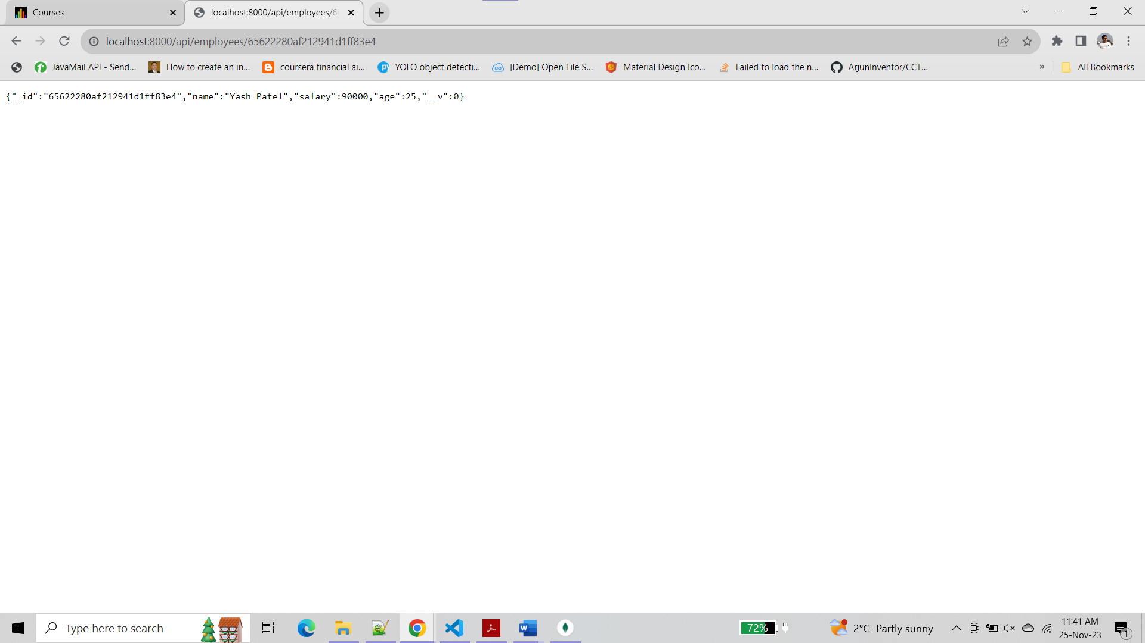

**Step 4 :-**

1. How does the Step 3:A, B,C work? Explain the work flow, route, and the way the query executed.

* **POST Request (Step3: A):**

**Client (Postman):** Sends a POST request to http://localhost:8000/api/employees with employee data in the body.

**Server (app.js):** Handles the request using the /api/employees route.

**Server (app.js):** Uses Employee.create to create a new employee record in the MongoDB database.

**Server (app.js):** Responds with a JSON array containing all employees, including the newly added one.

* **GET Request (Step3: B):**

**Client (Browser):** Sends a GET request to http://localhost:8000/api/employees.

**Server (app.js):** Handles the request using the /api/employees route.

**Server (app.js):** Uses Employee.find to retrieve all employee records from the MongoDB database.

**Server (app.js):** Responds with a JSON array containing all employees.

* **GET Request for Specific Employee (Step3: C):**

**Client (Browser):** Sends a GET request to http://localhost:8000/api/employees/65622280af212941d1ff83e4.

**Server (app.js):** Handles the request using the /api/employees/:employee_id route.

**Server (app.js):** Uses Employee.findById to retrieve the employee record with the specified _id from the MongoDB database.

**Server (app.js):** Responds with a JSON object representing the specific employee.

1. What is the role of:
2. module.exports = mongoose.model('Employee', EmpSchema);

* This line exports the Mongoose model for the "Employee" schema. It allows other parts of the application to use the "Employee" model to interact with the MongoDB collection associated with this schema.

1. Employee.findByIdAndUpdate

* This Mongoose method is used to find a document by its _id and update it with the provided data. It takes three parameters: the _id of the document to update, the data to update, and a callback function.

1. Using the idea of Step3: C, try to update one of the record in the employee table .Find related route in the code and explain how it works.

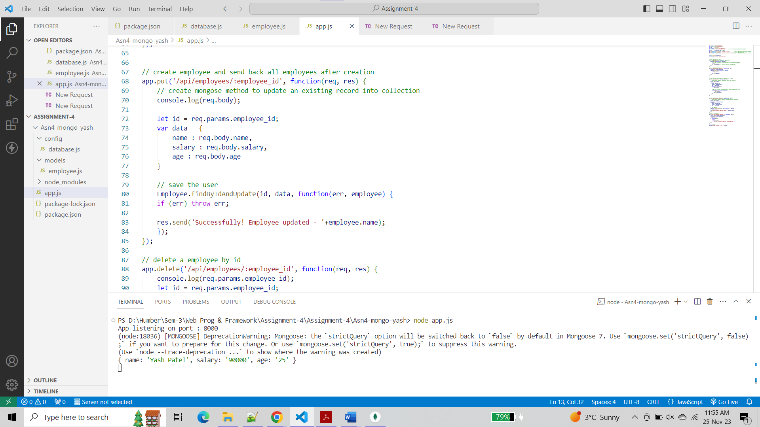

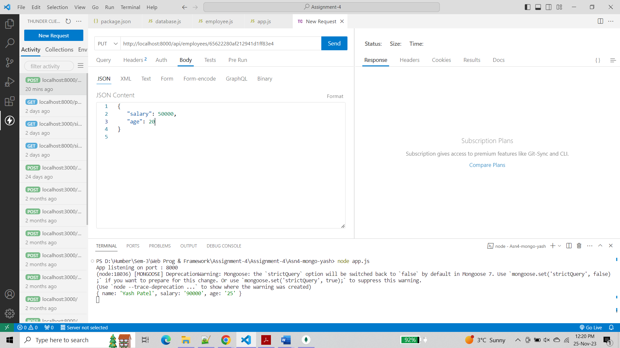

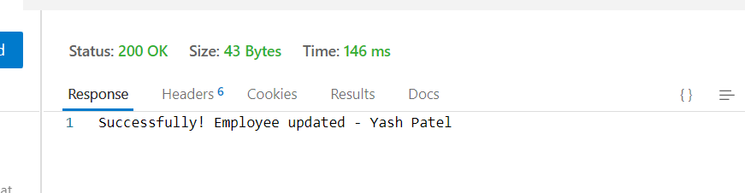

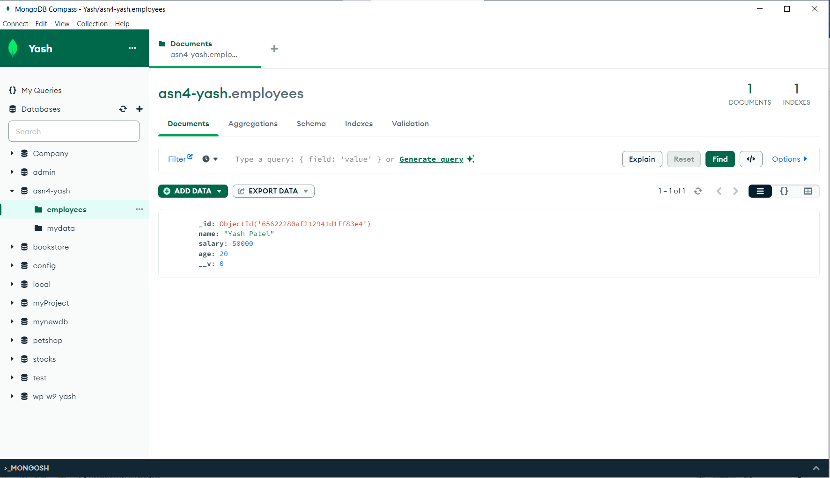

* When a PUT request is made to /api/employees/:employee_id, the server uses Employee.findByIdAndUpdate to find the employee with the specified _id and update it with the data provided in the request body.
* And then the server responds with a success message or an error.

1. Using the idea of Step3:C, try to delete one of the record in the employee table. Find related route ☺ in the code and explain how it works.

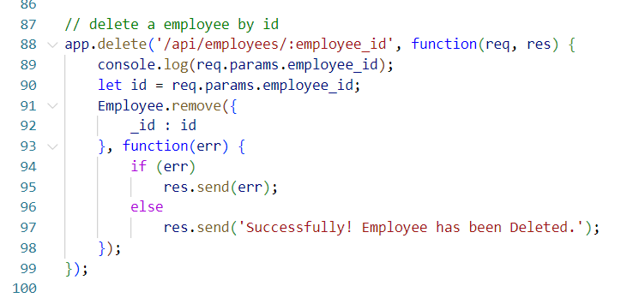

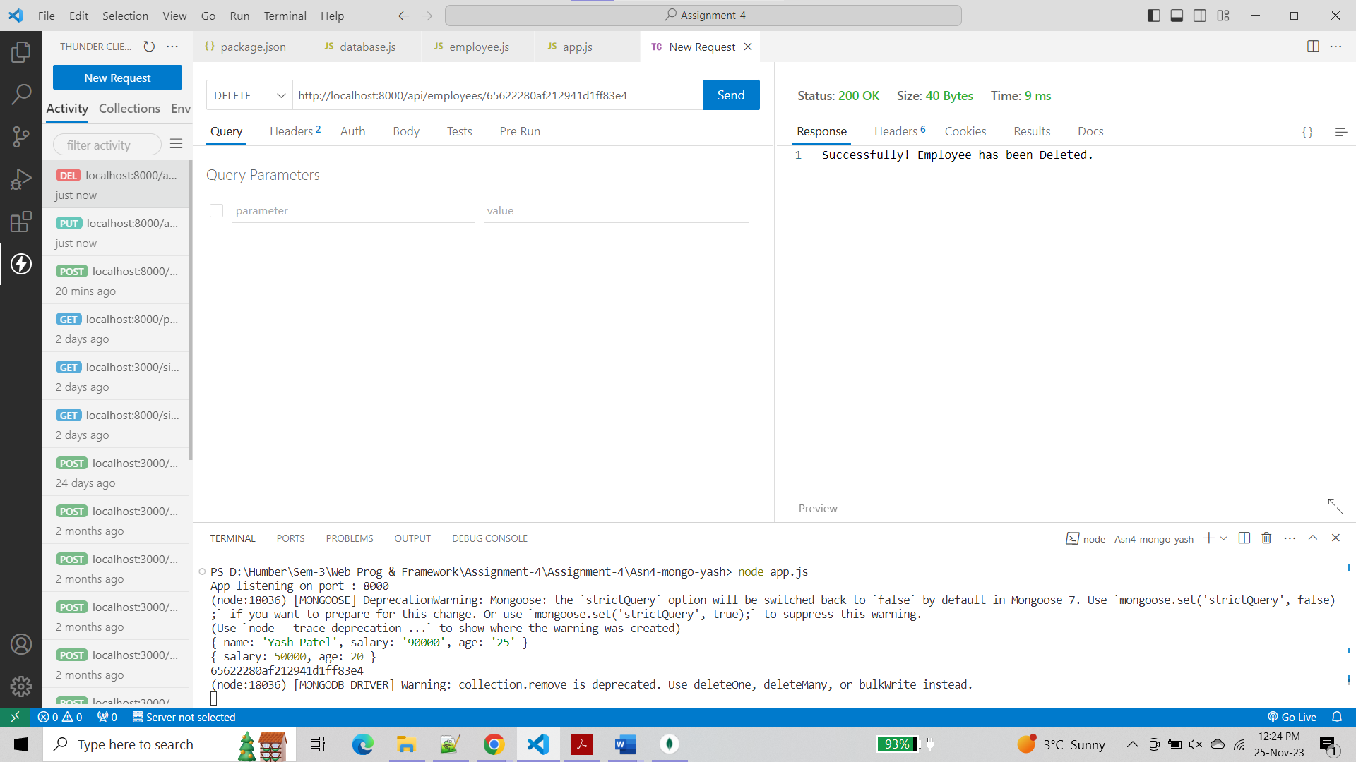

* When a DELETE request is made to /api/employees/:employee_id, the server uses Employee.remove to find the employee with the specified _id and remove it from the database.
* Then the server responds with a success message or an error.

**Question 2 :-**

**Step 1 :-**

Created a new database in Atlas

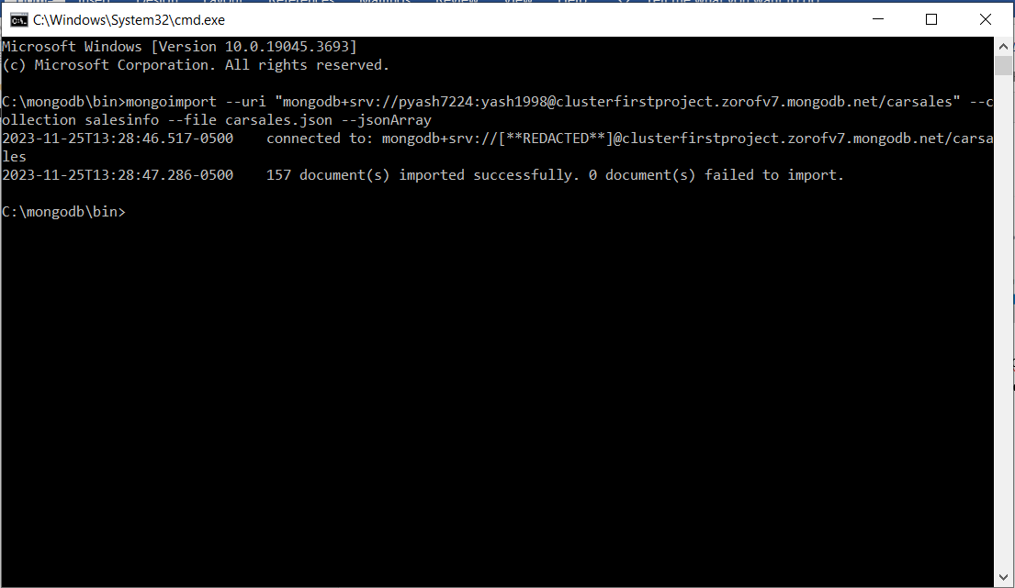

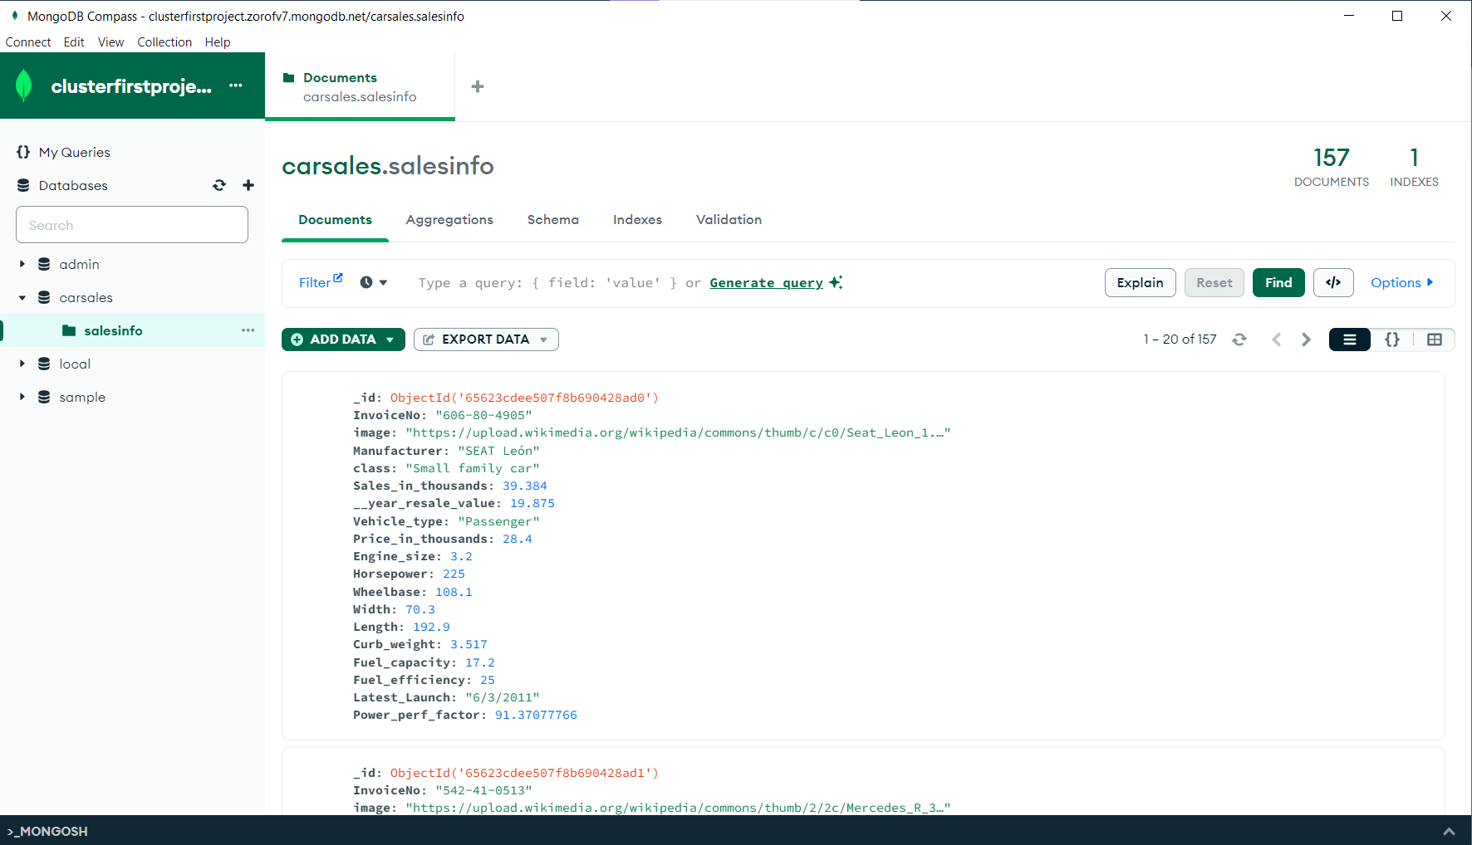

**Step 2:-**

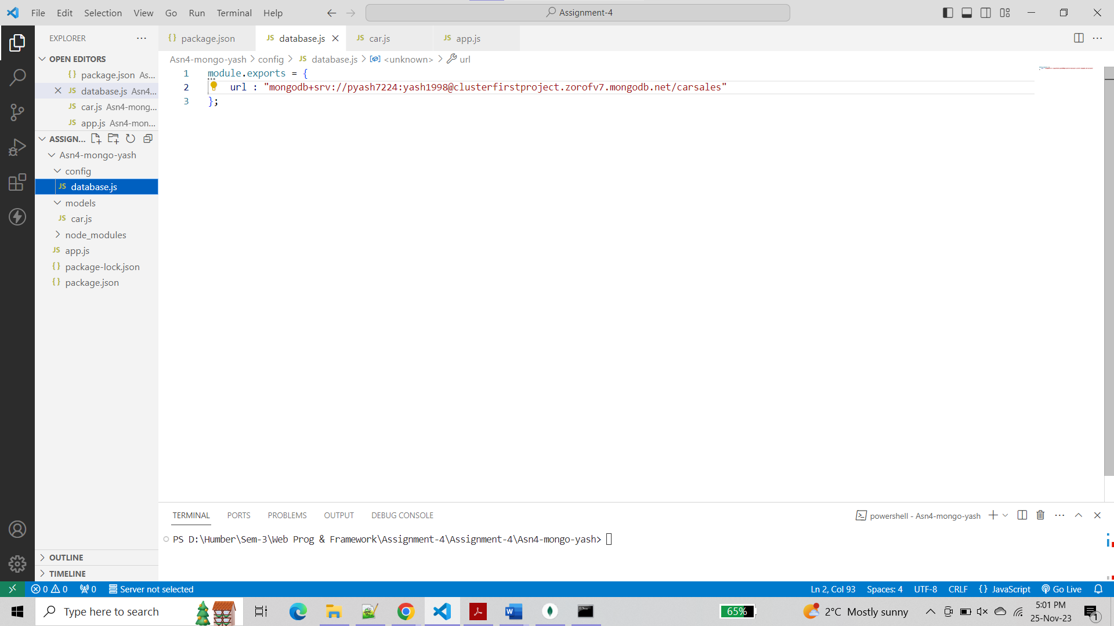

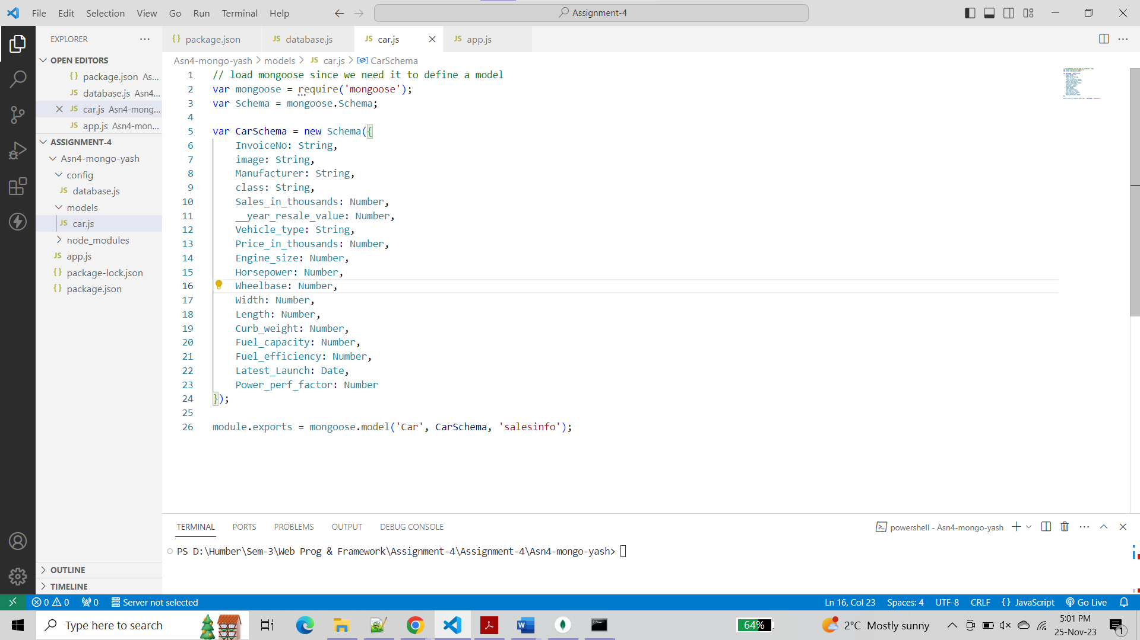

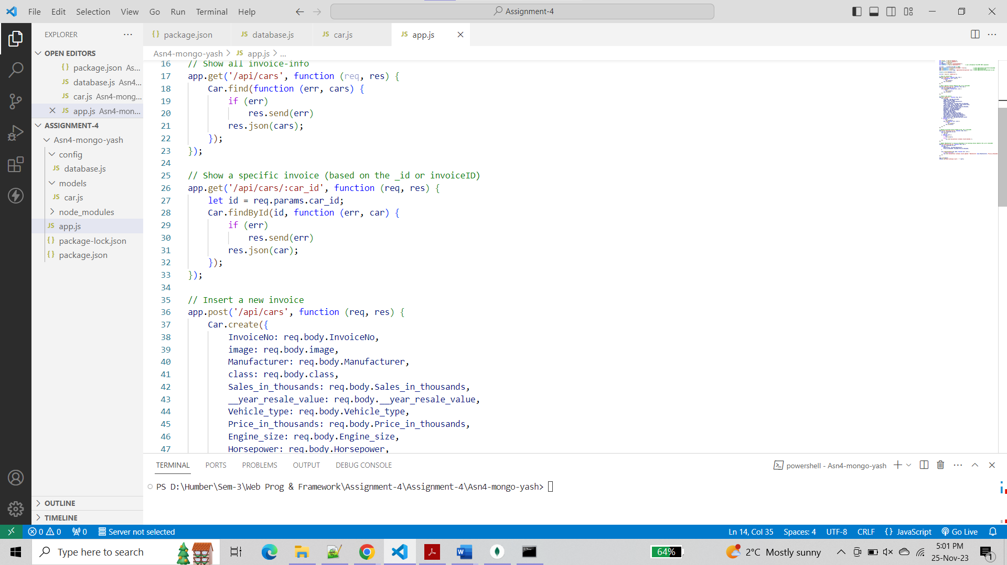

1. Show all invoice-info

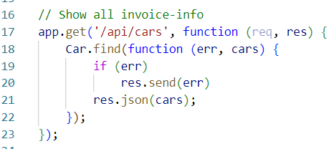

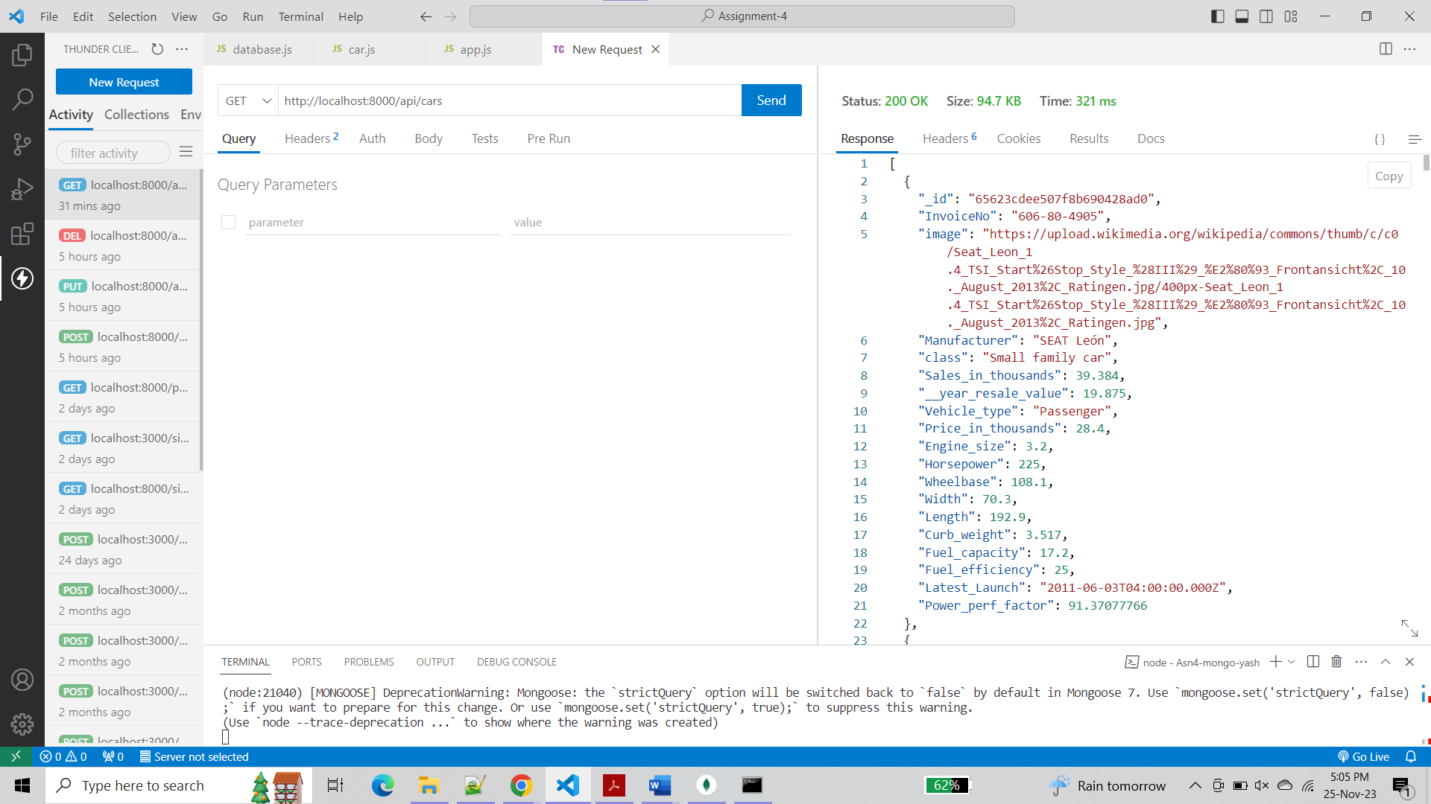

1. Show a specific invoice (based on the _id or invoiceID)

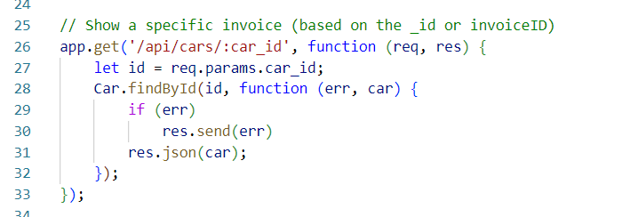

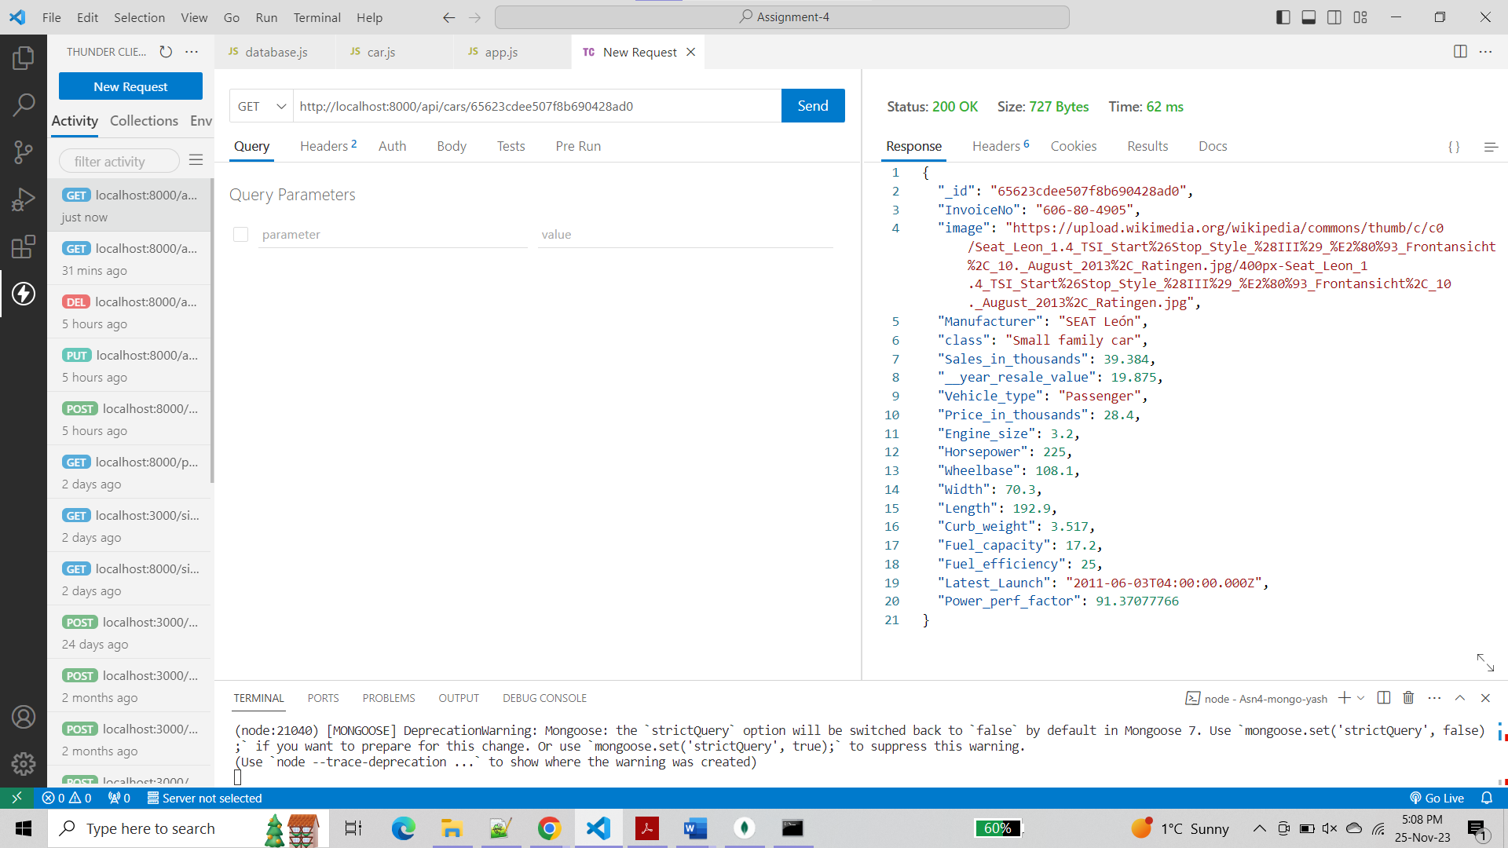

1. Insert a new invoice

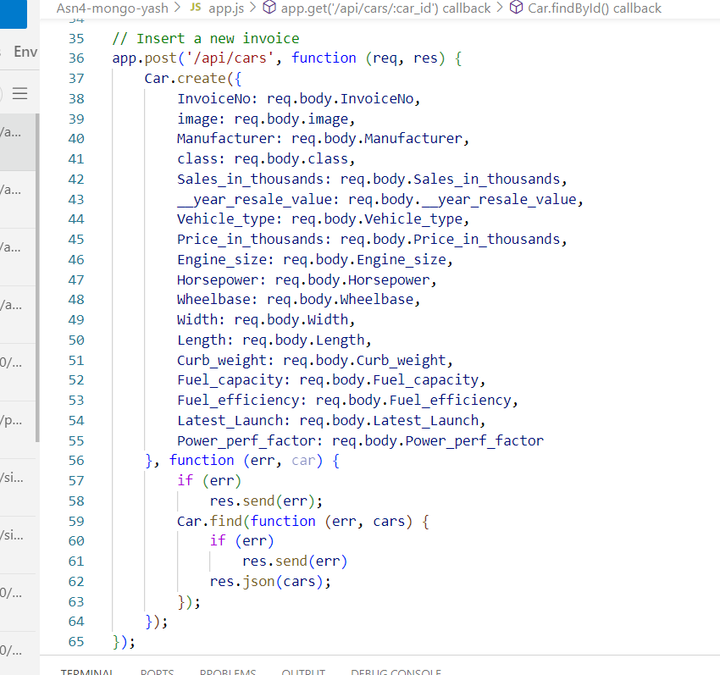

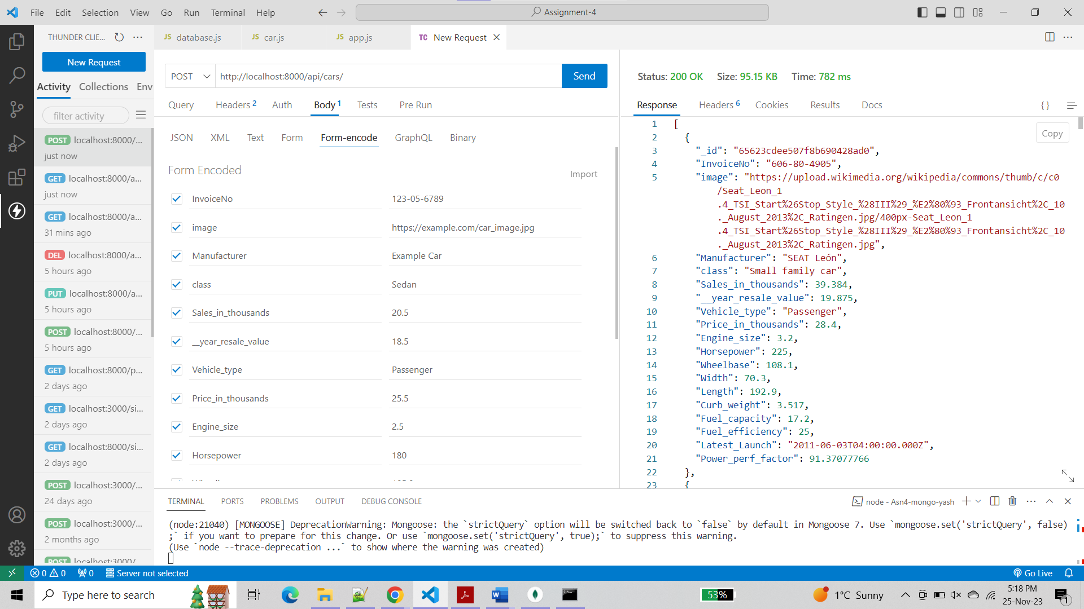

You can see below that my record is inserted

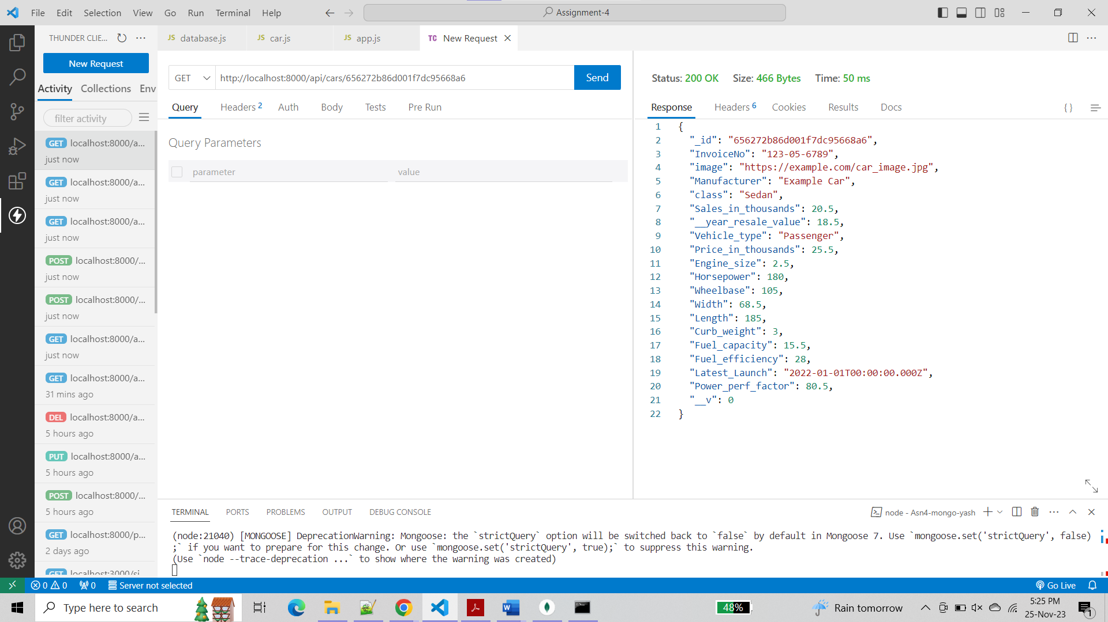

1. Delete an existing invoice (based on the _id or invoiceID)

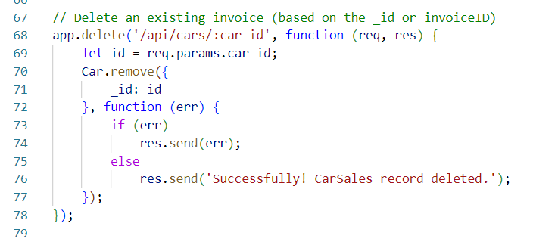

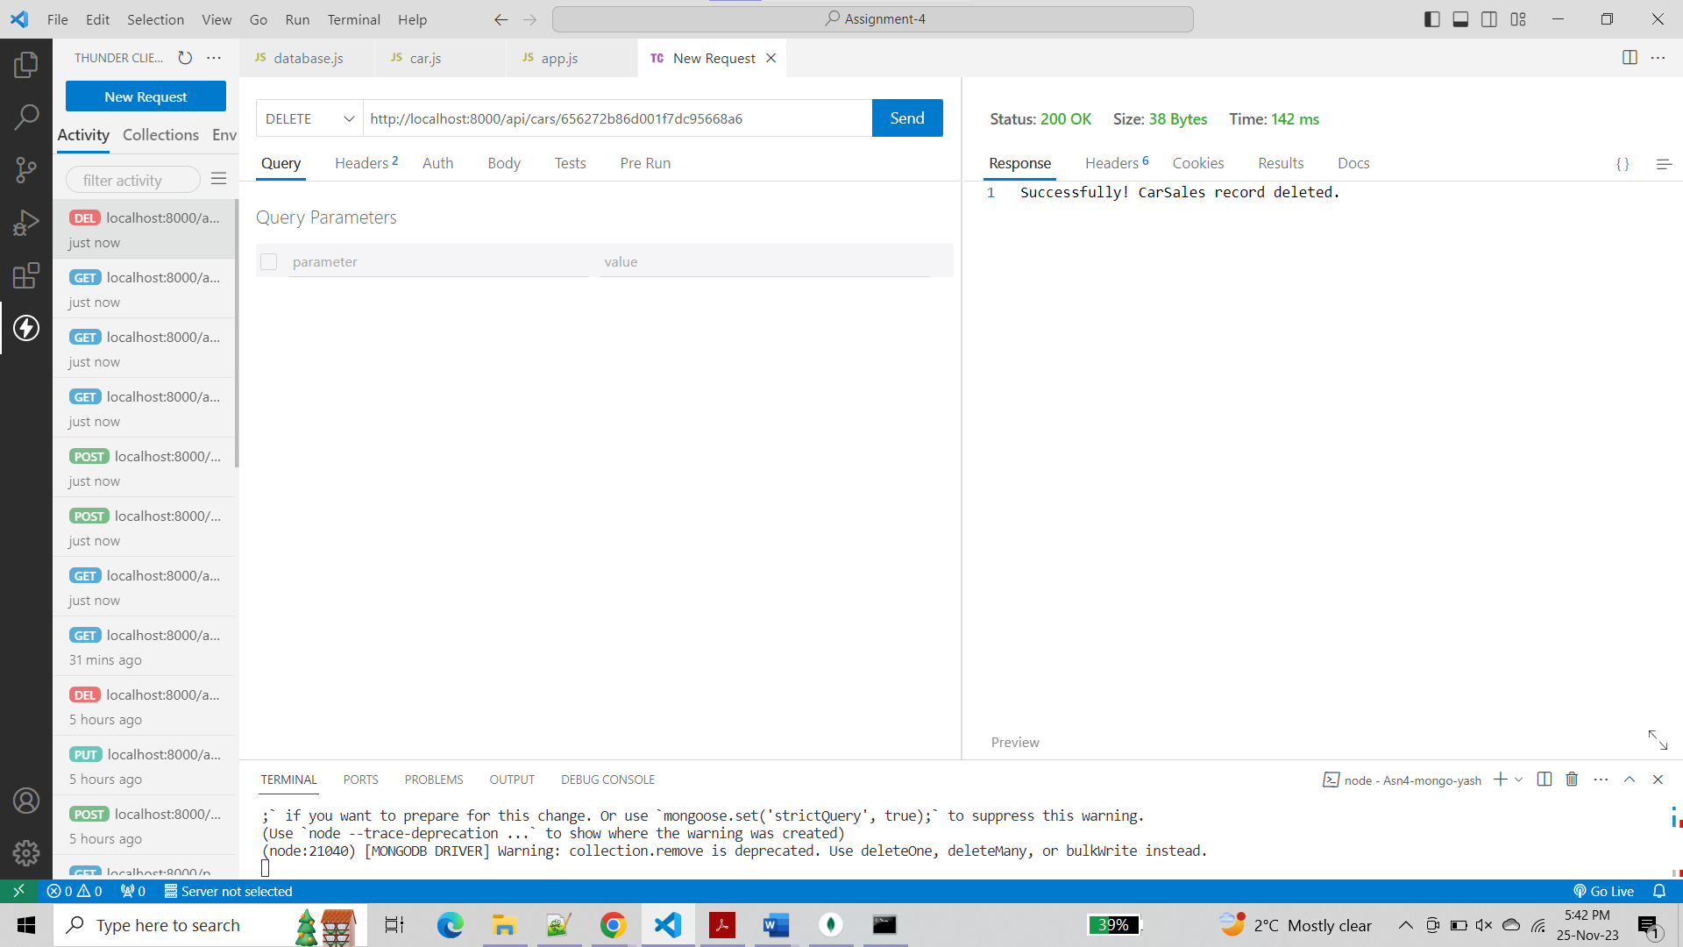

1. Update "Manufacturer" & “price_in_thousands” of an existing invoice (based on the _id or invoiceID)

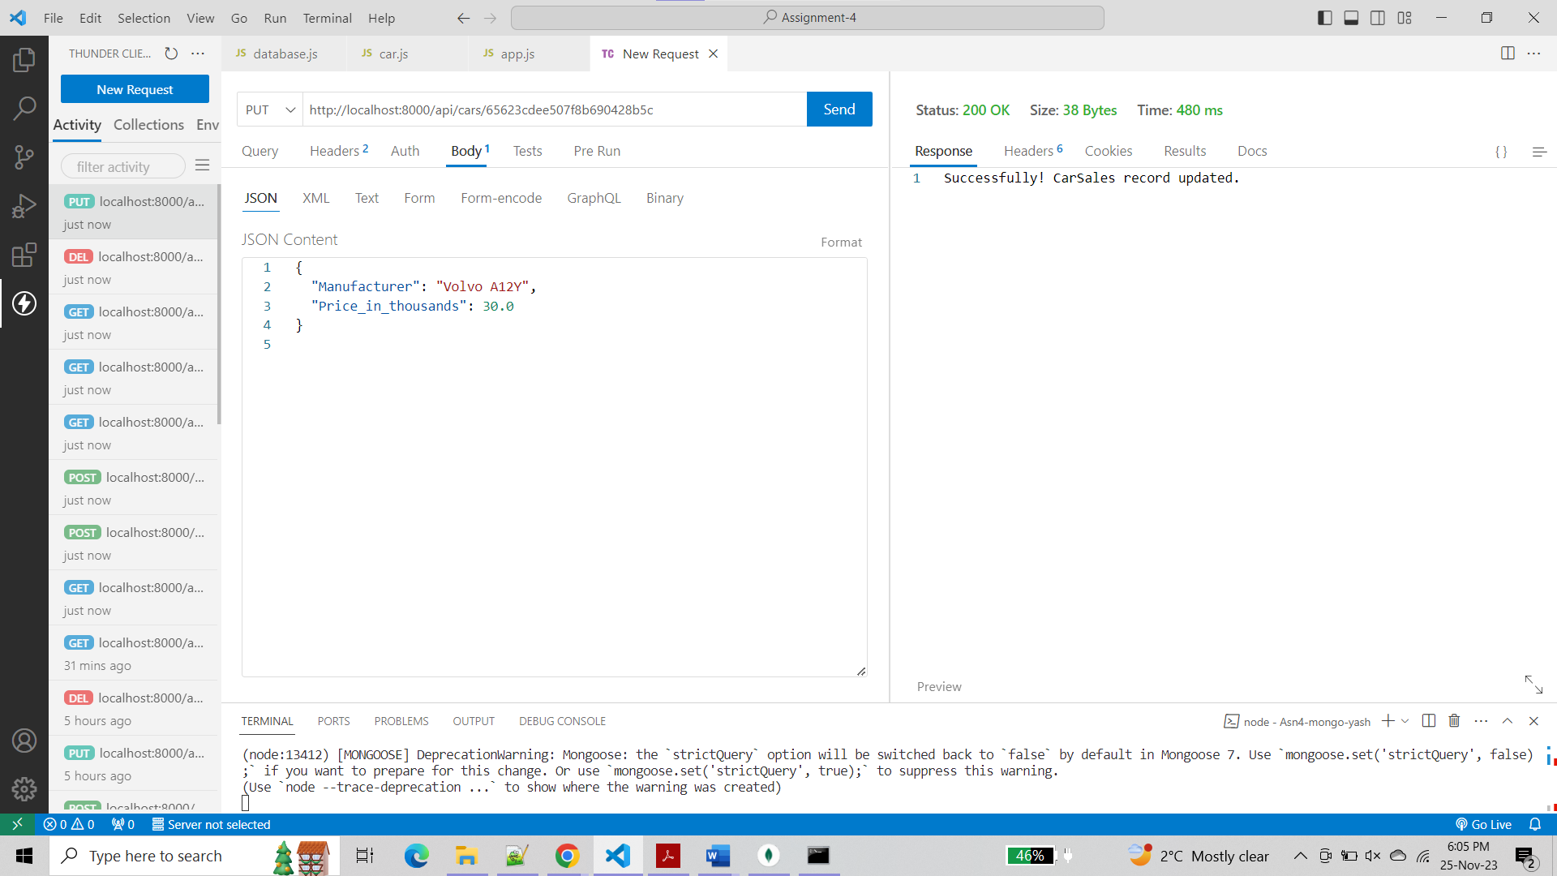

You can see below that both the values are updated in the record.

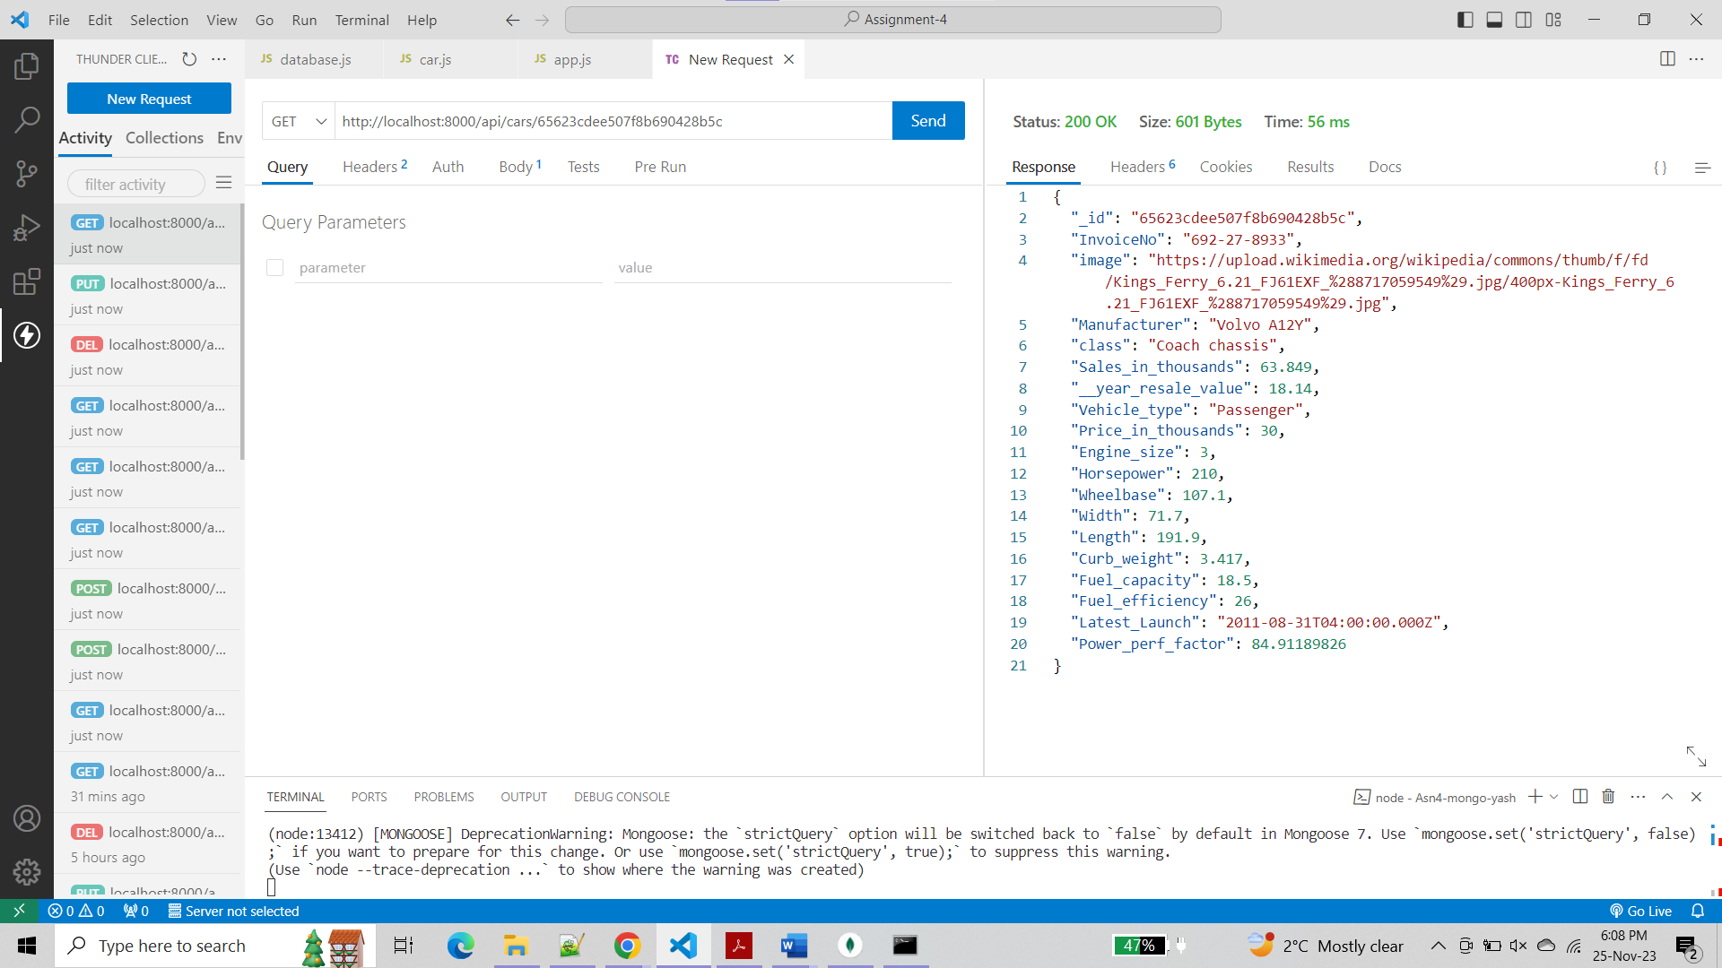

1. Using Handlebar and Form complete the followings

* Show all invoice-info

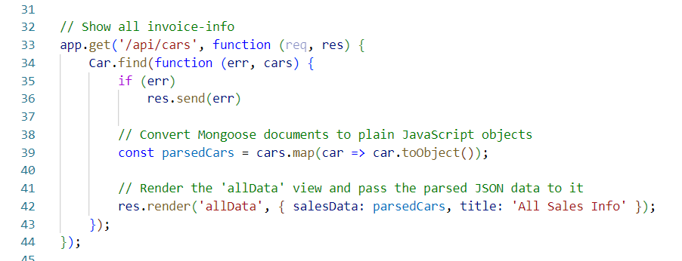

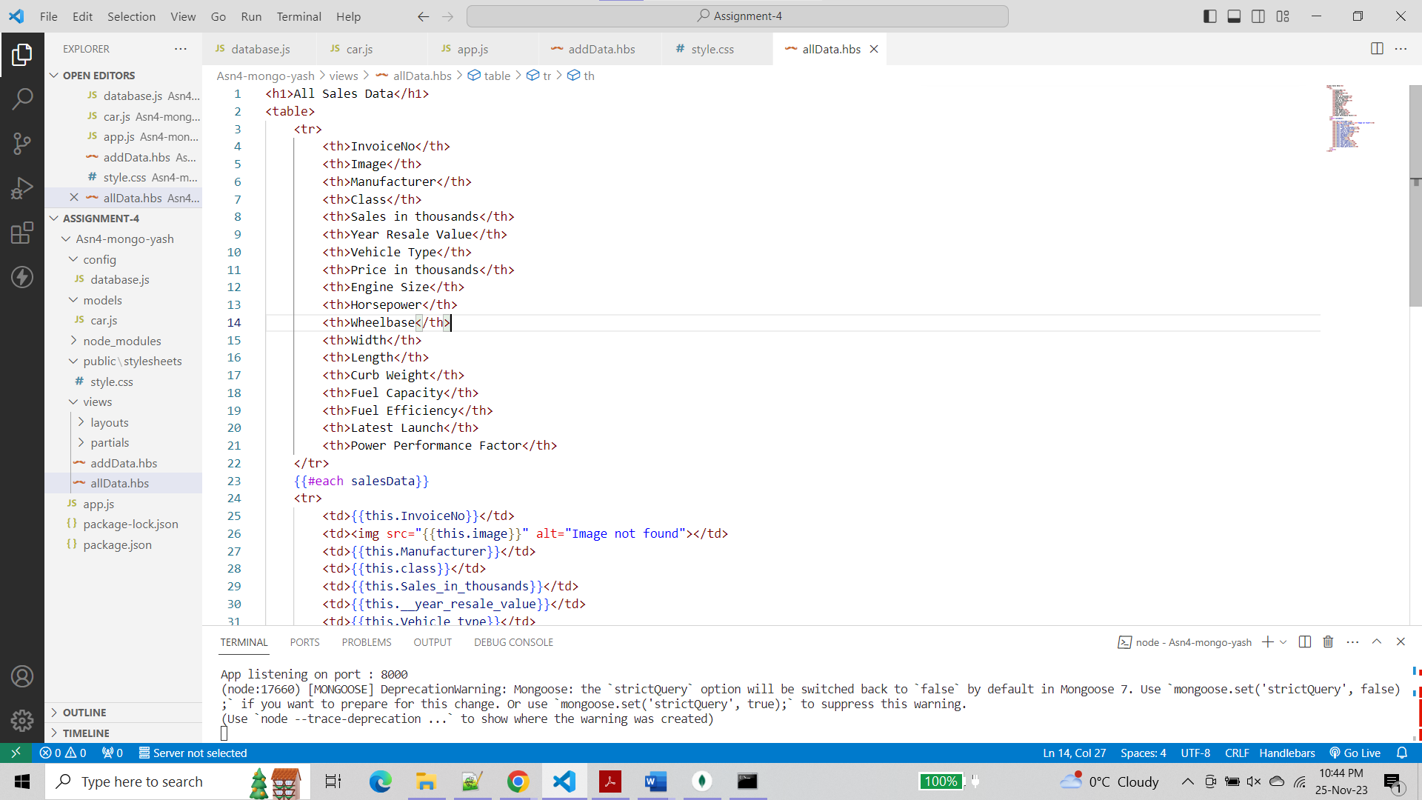

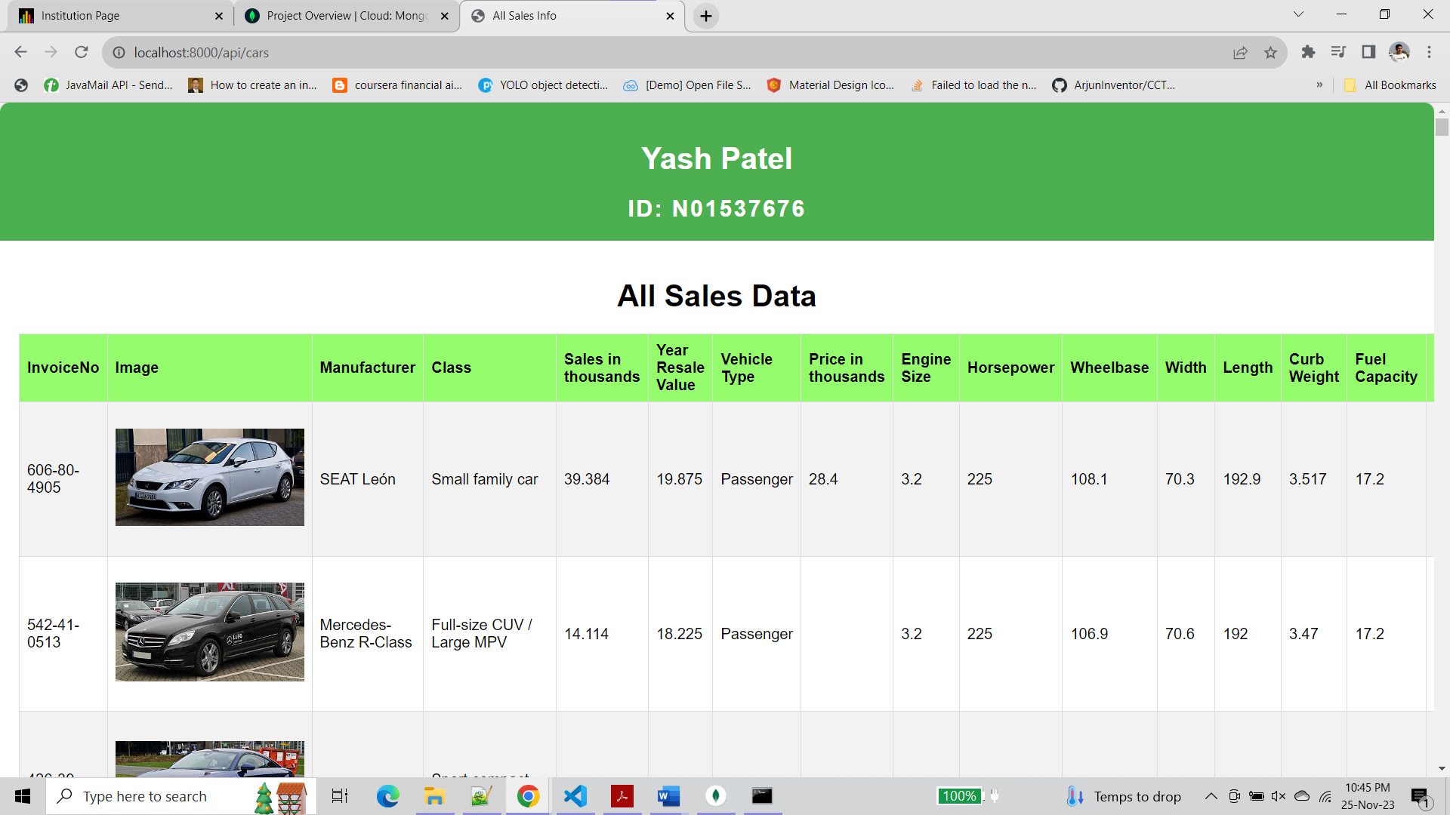

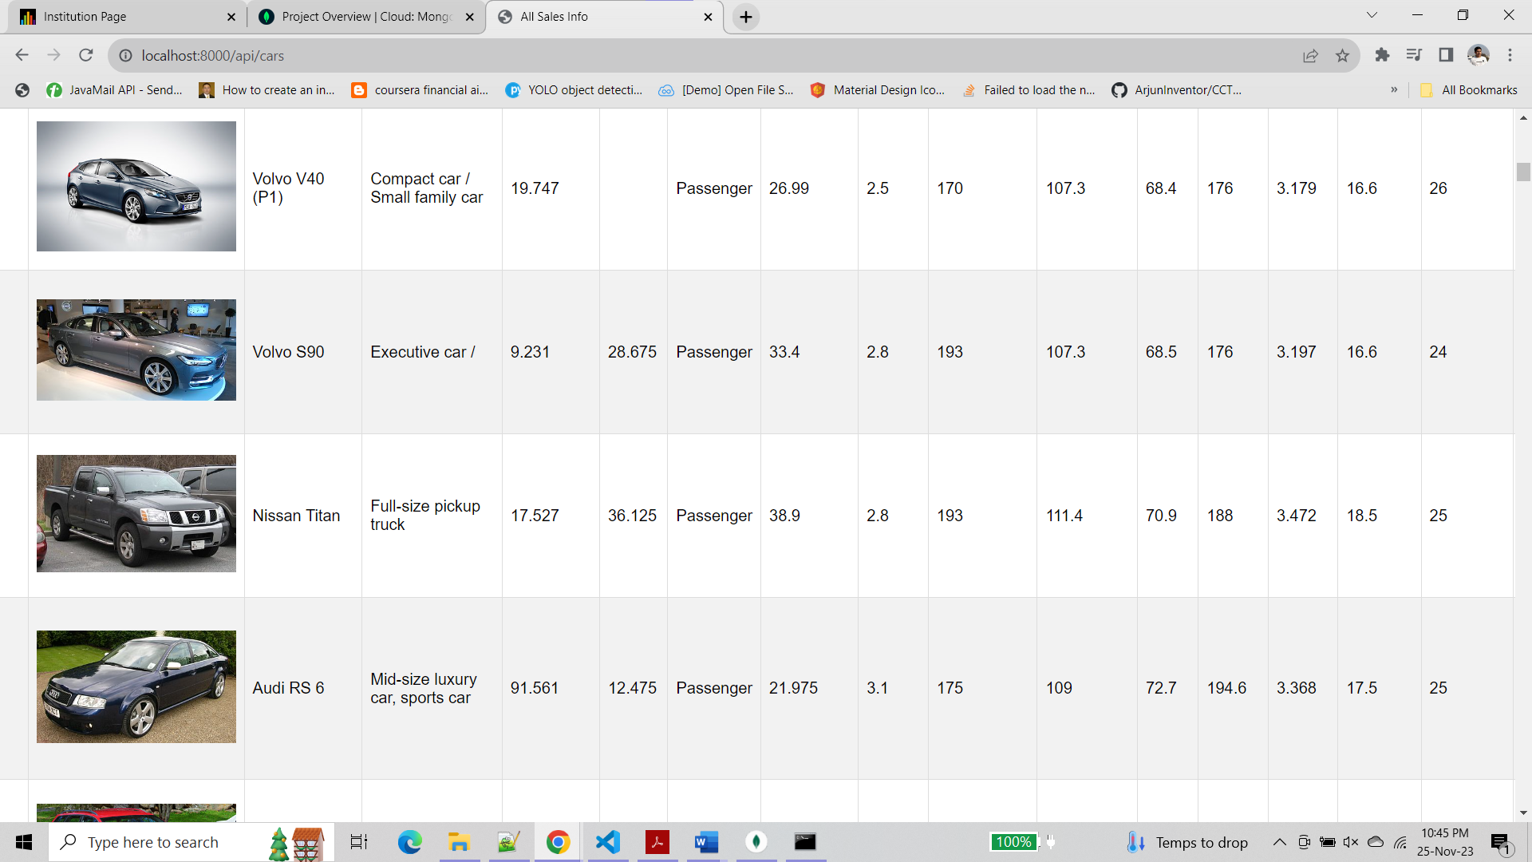

* Insert a new invoice

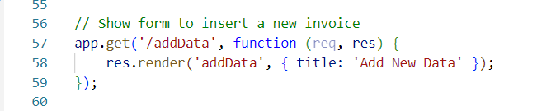

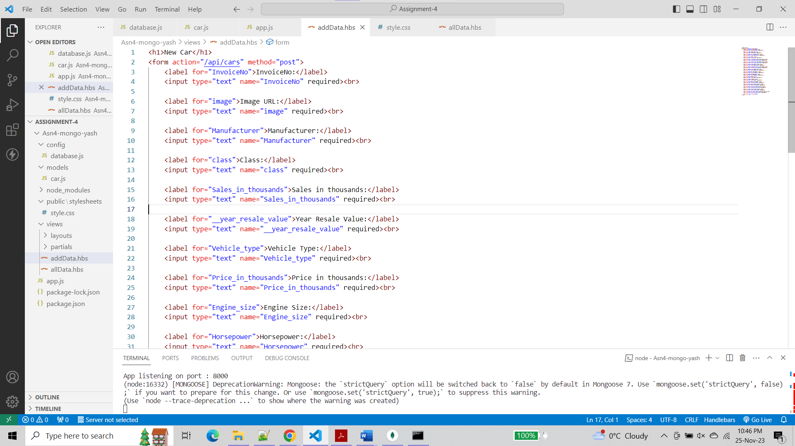

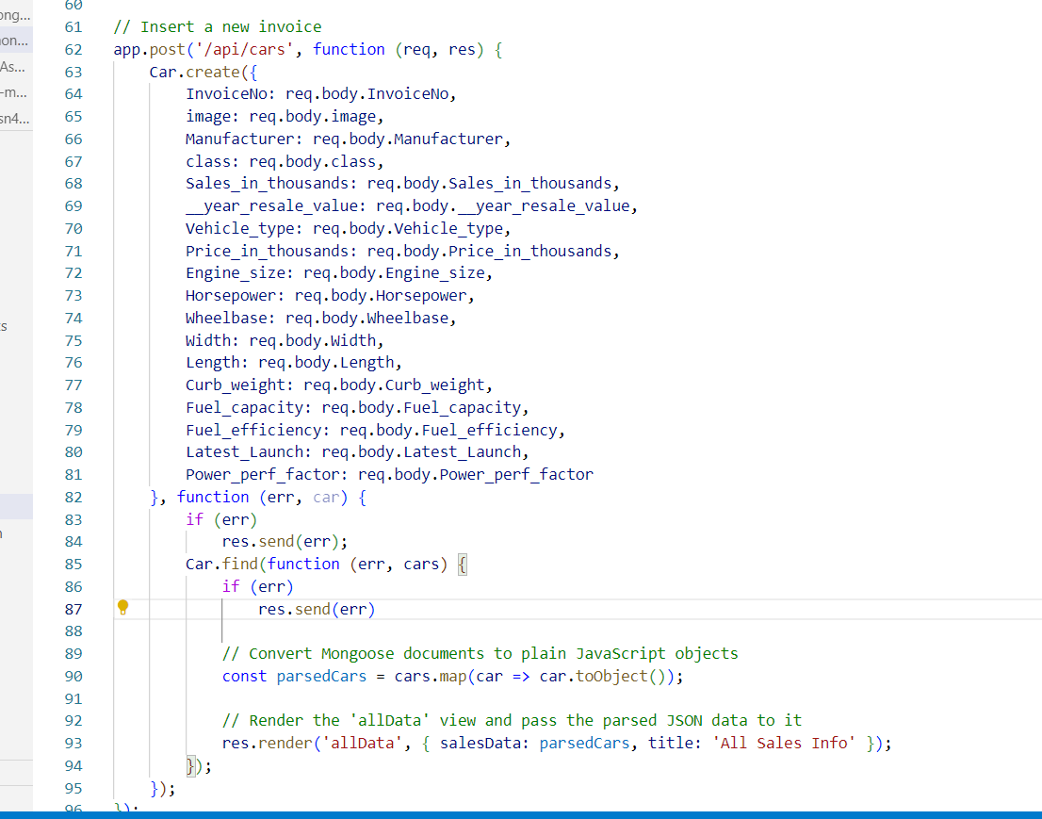

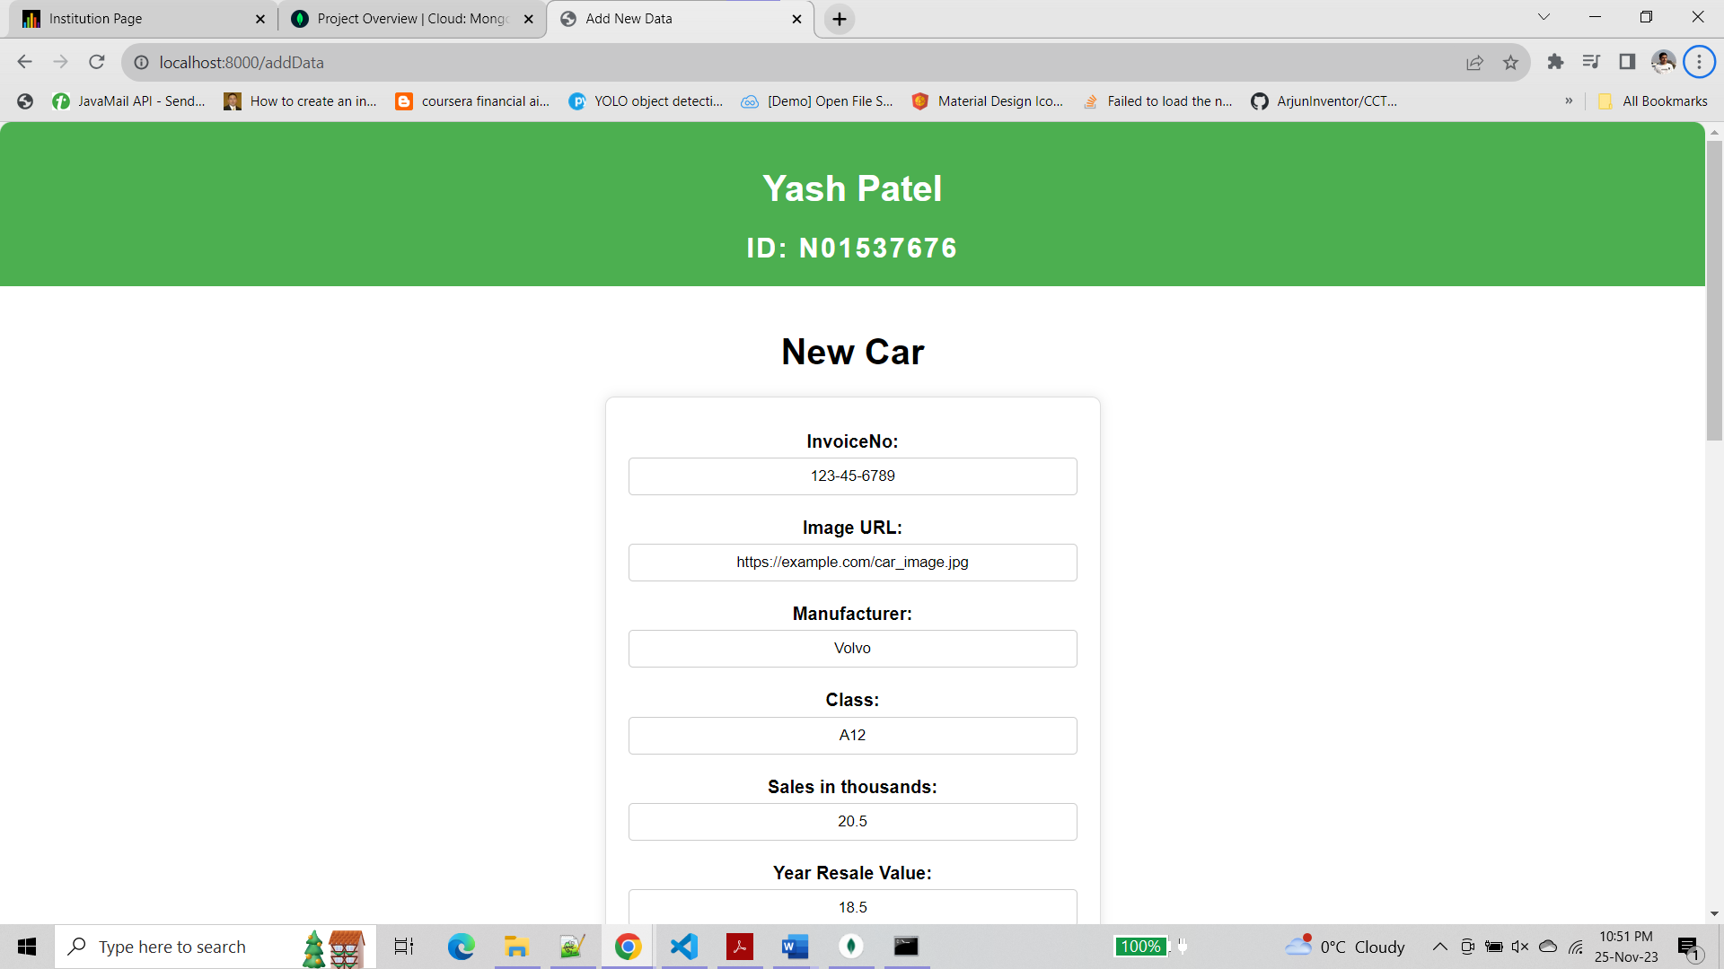

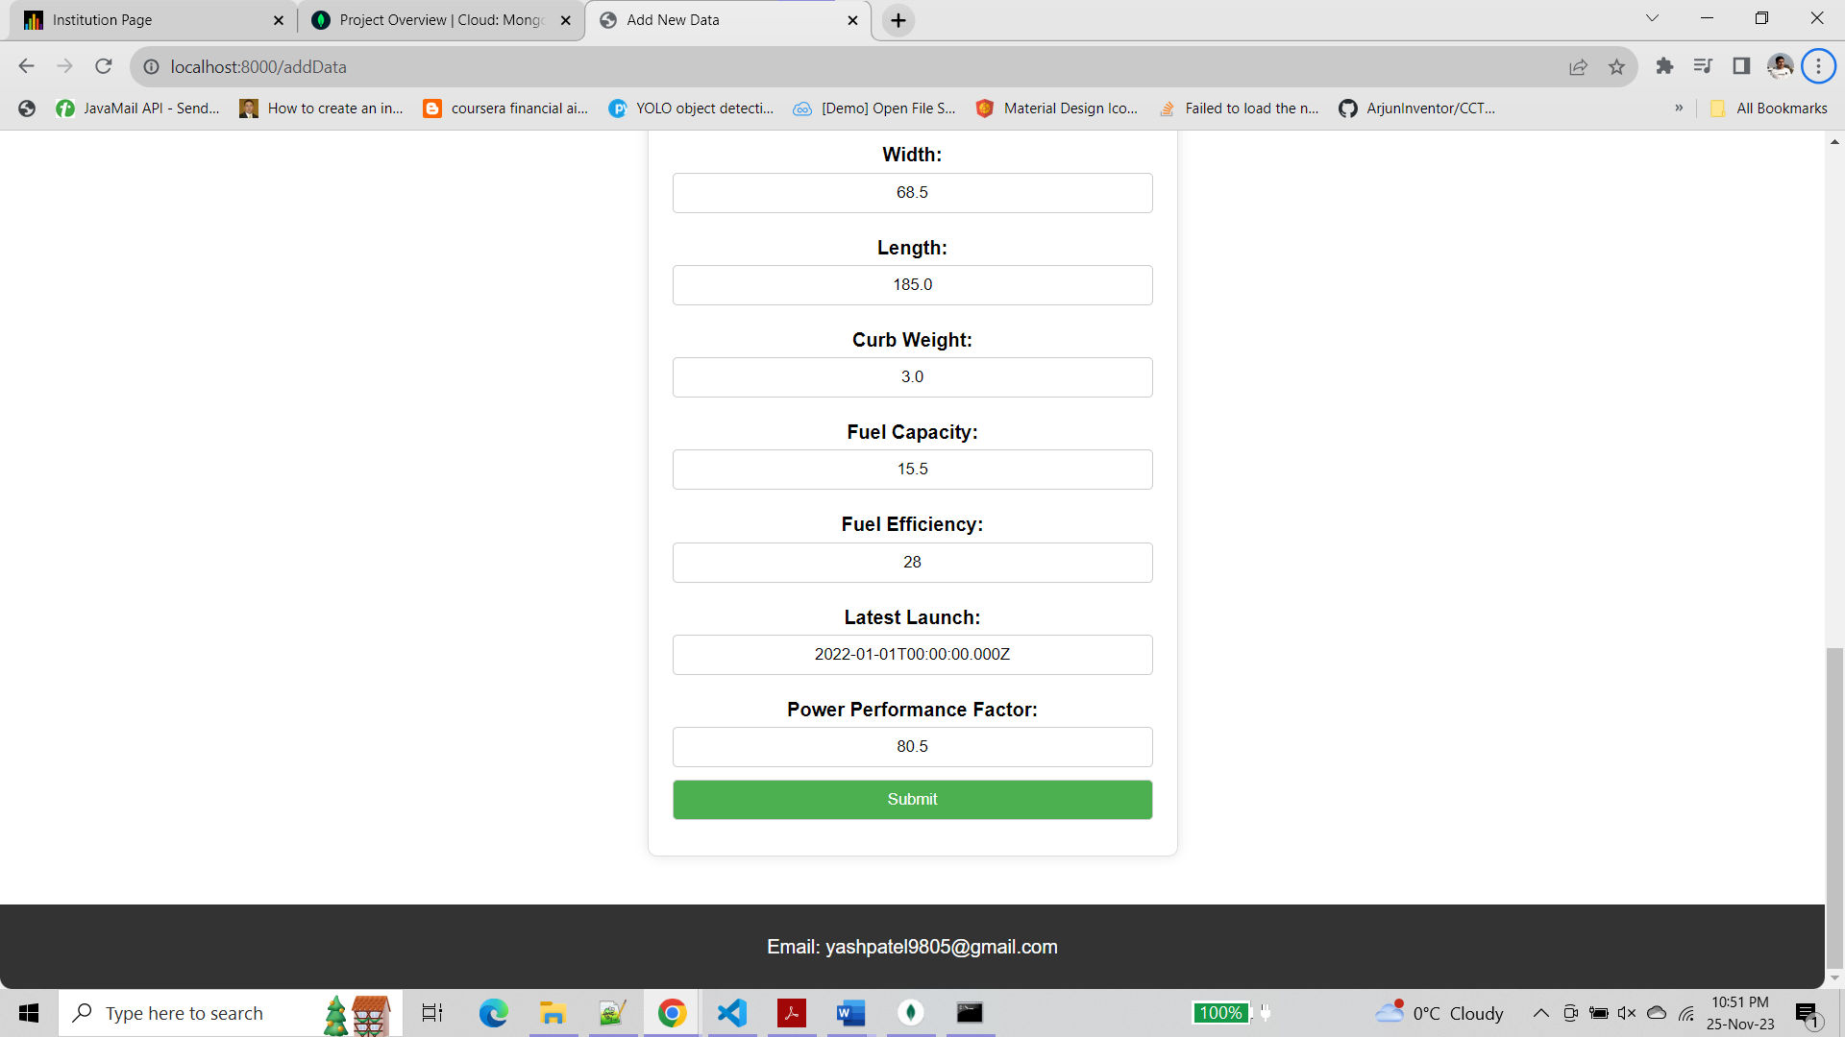

You can see below that new record has been added to the database.

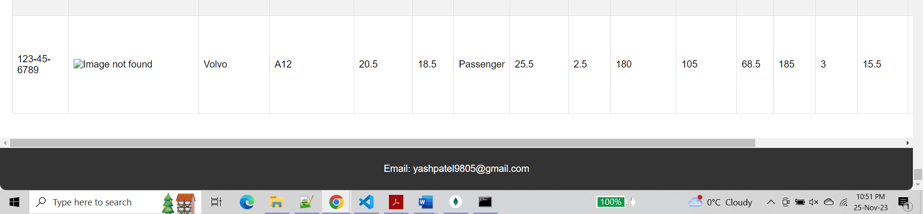

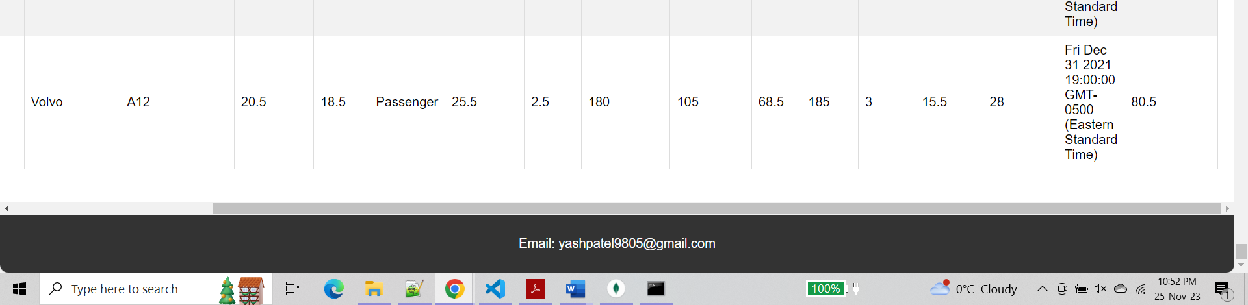

**Step 3 :-**

Added a new search by manufacturer functionality to the app

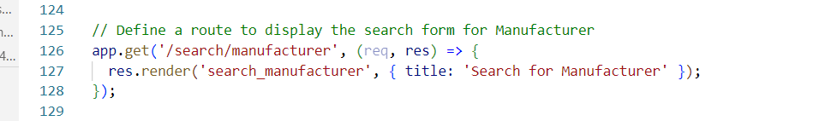

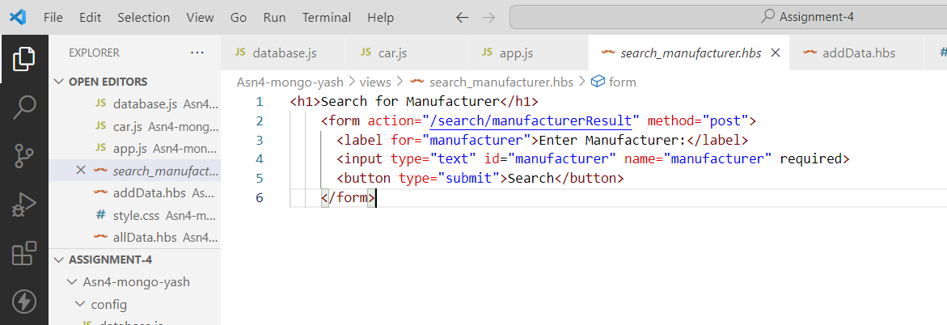

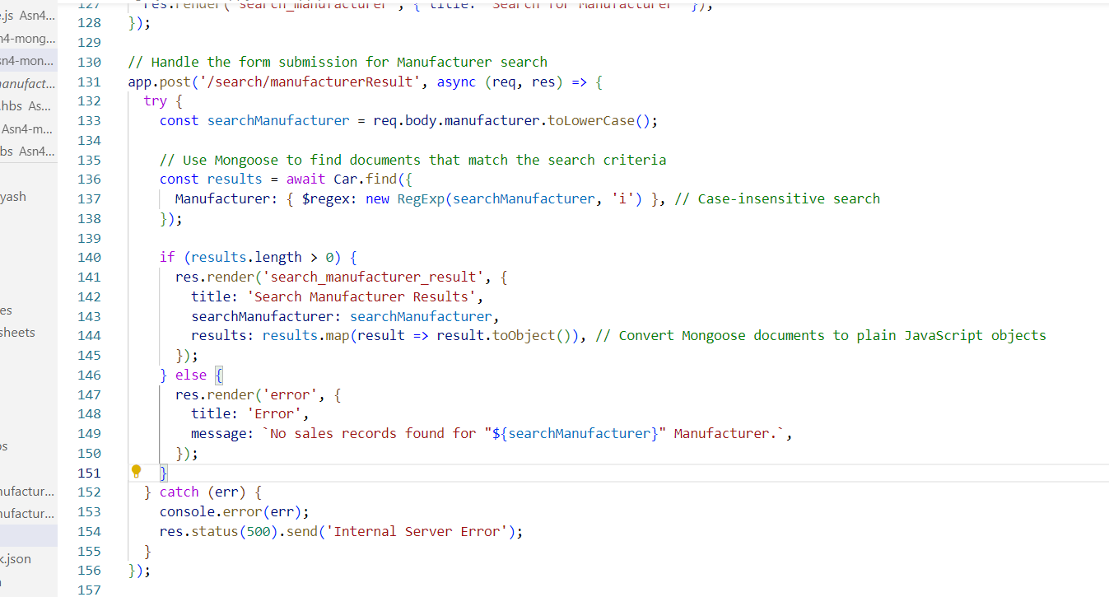

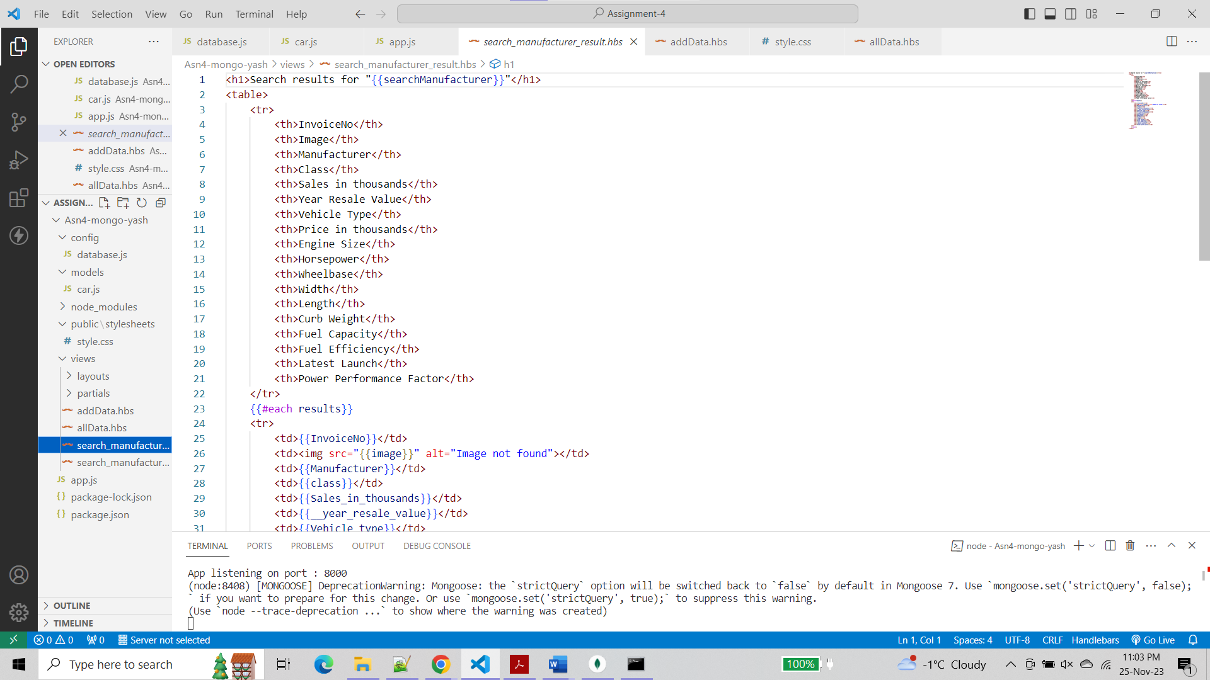

**Output :-**

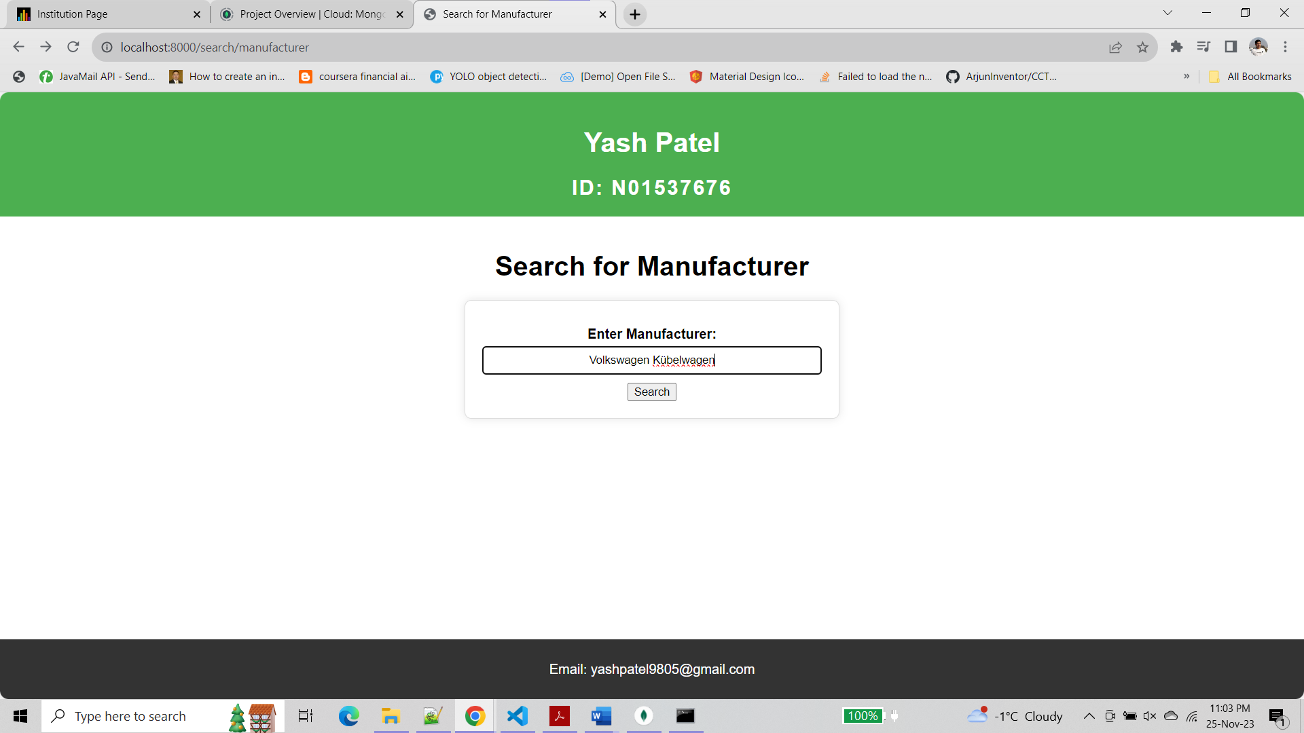

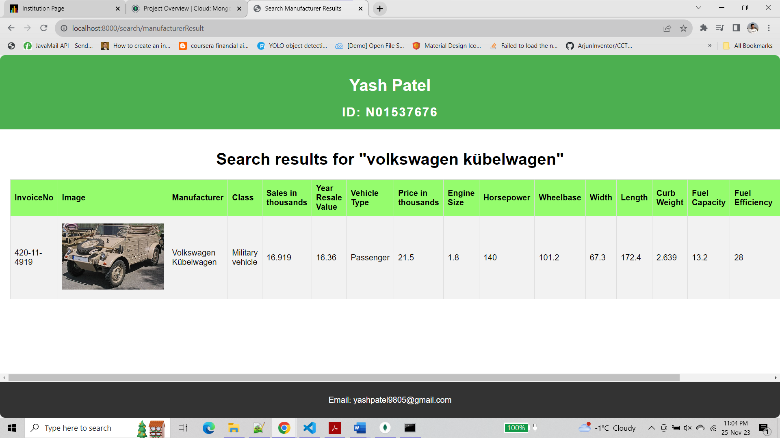

Matching partial string

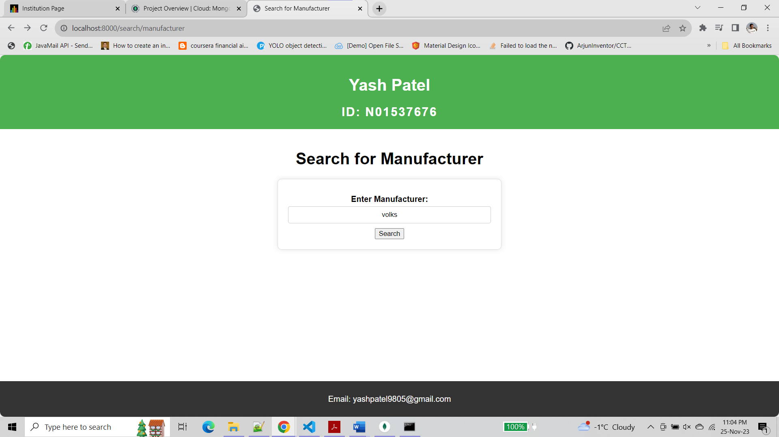

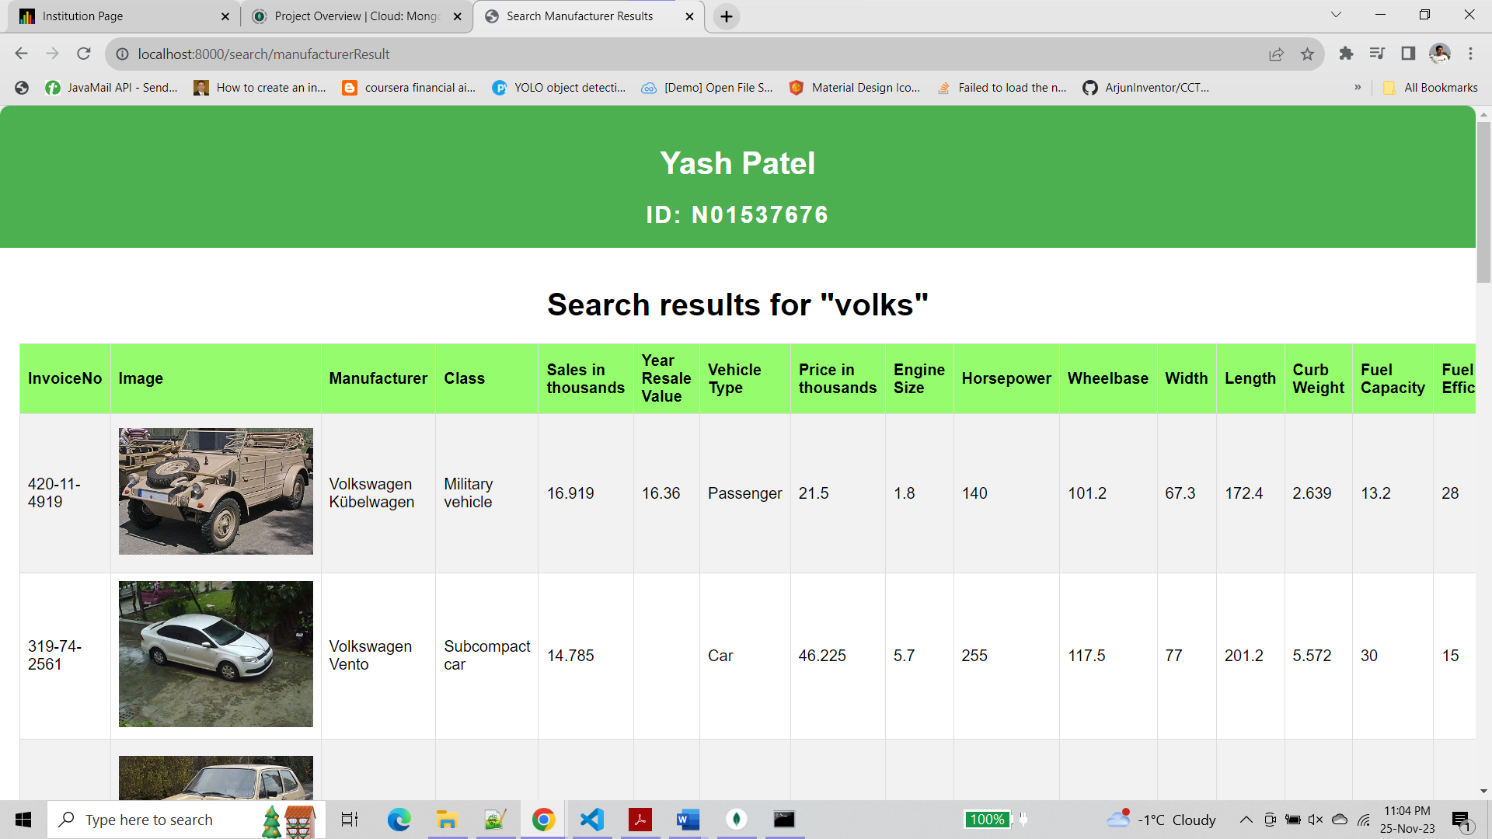

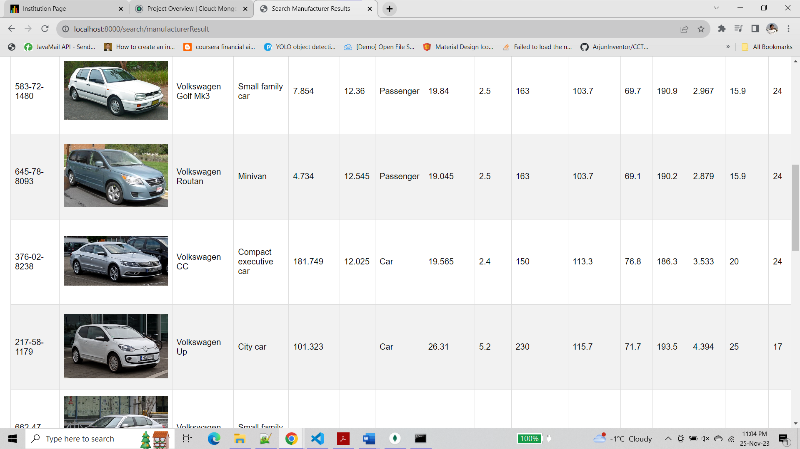

**Step 4 :-**

Deploy the app to cyclic

**Link :-** <https://sore-gold-cockroach-wear.cyclic.app/>

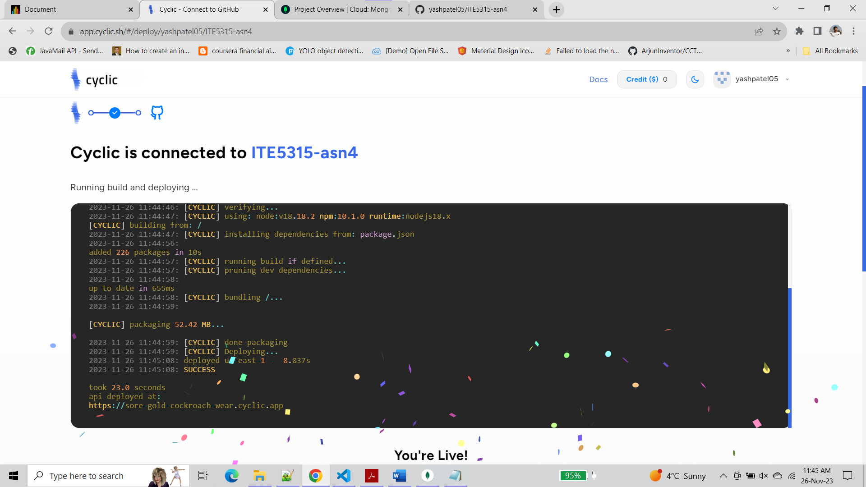

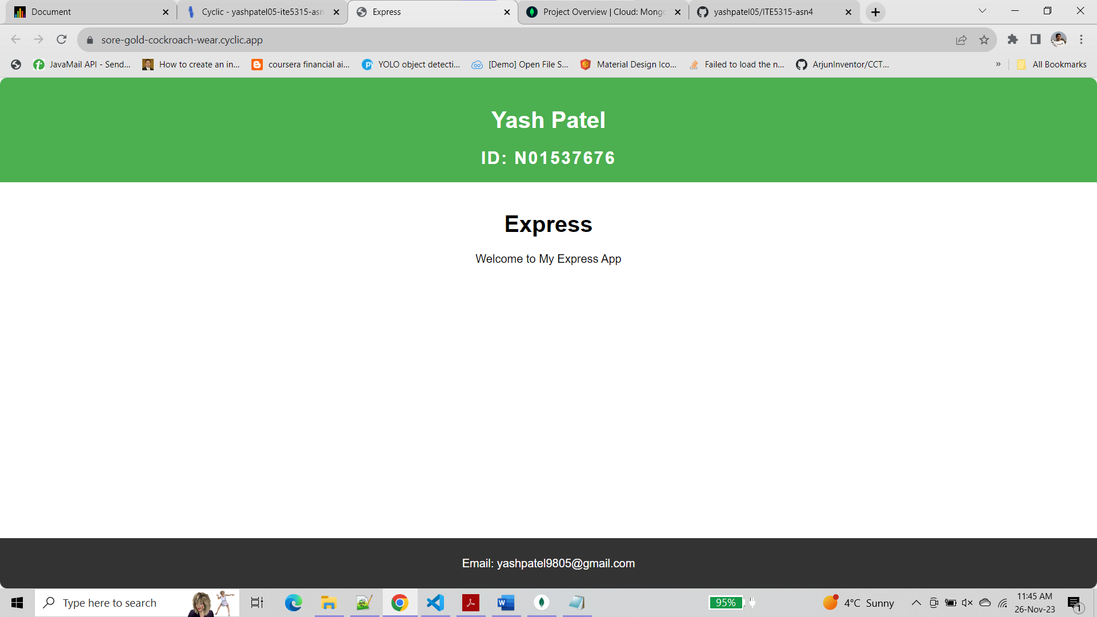

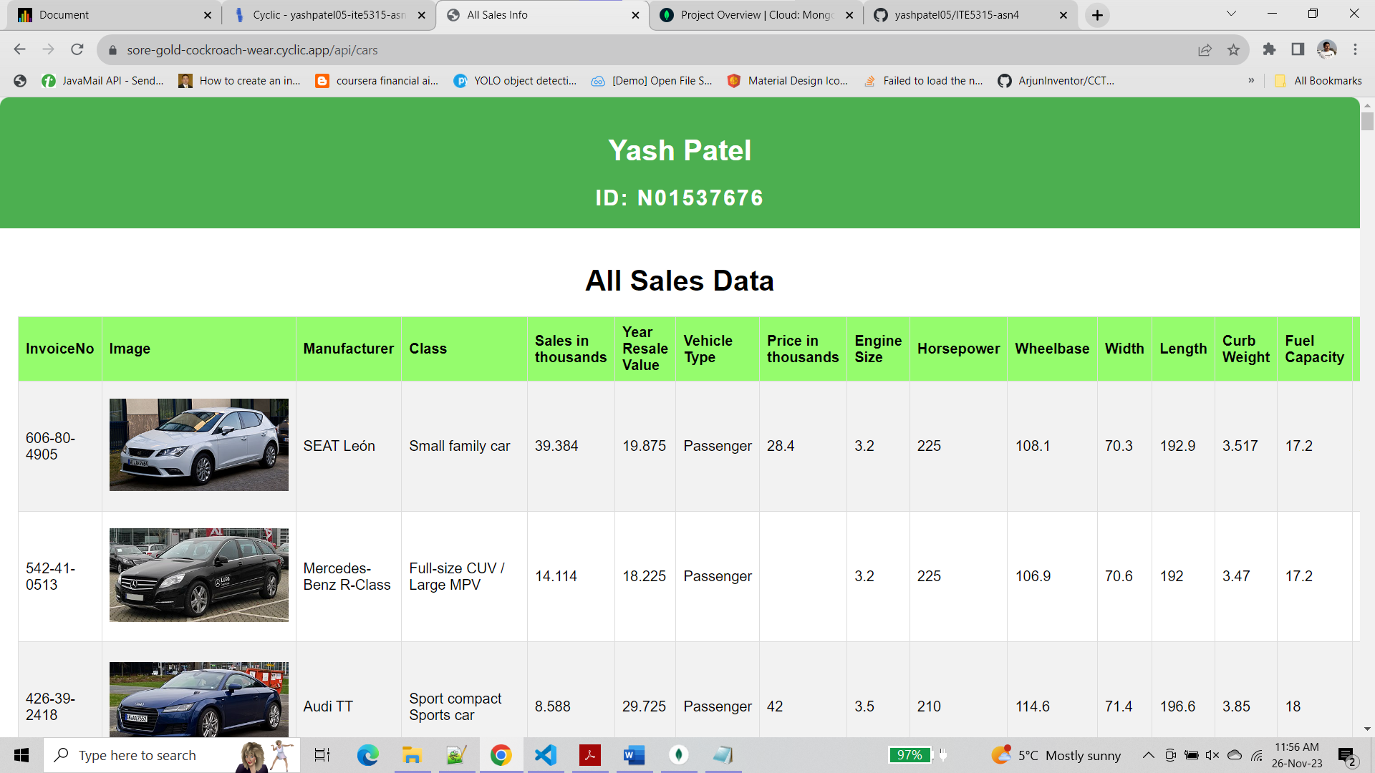

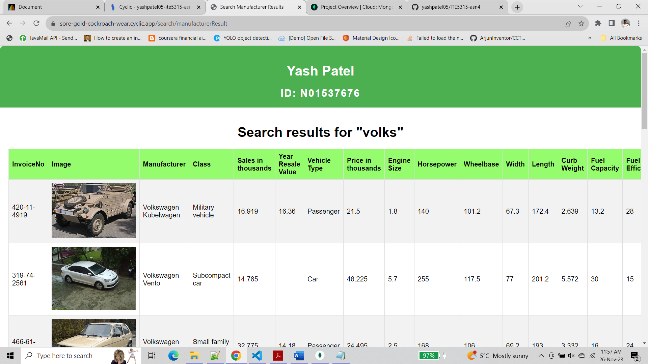

**Question 3 :-**

**Step 1 :-**

run it using nodemon. Look at the output of the program.

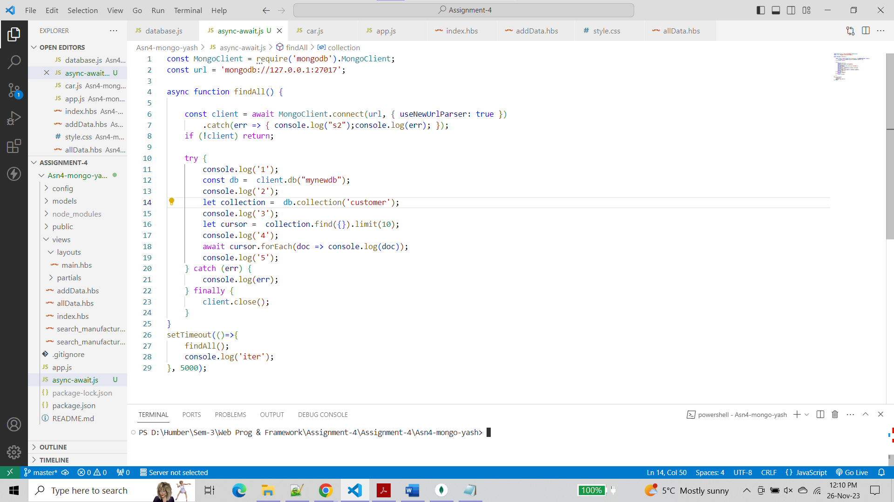

**Output :-**

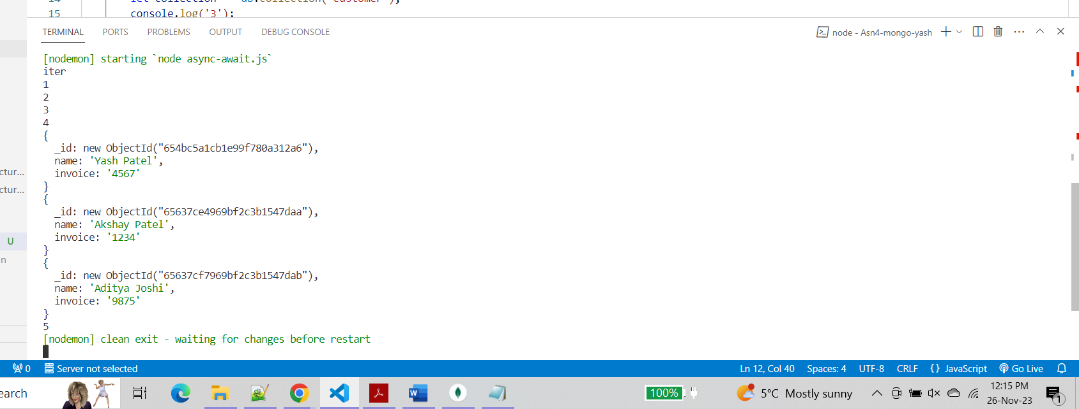

This output indicates that the program is connecting to the MongoDB database, querying the "customer" collection, and printing the first 10 documents.

**Step 2 :-**

What if you remove wait from Task1, any error? Explain what have you learned

* If we remove the await from await MongoClient.connect(...), we will encounter an issue. The client variable will be a promise instead of the actual MongoClient instance. So when we try to access client.db("mynewdb"), it will throw an error because the promise does not have a db method.

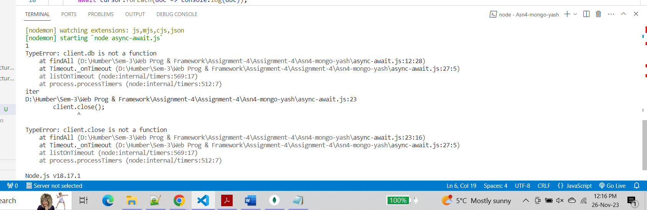

**Step 3 :-**

What if you remove all await/async from the task1 and 2. How do you explain changes in the output compare to Step 1?

* If we remove all await/async from Task1 and Task2, we will get the same error like the Step-2 as promise “client” does not have a db method.
* But, If we remove the await from **cursor.forEach(doc => console.log(doc))**, the output will change. The code will no longer wait for asynchronous operations to complete, and the client.close() statement in the finally block will execute before the database query has a chance to complete. This may result in incomplete or no output from the database query, and we might see the program exiting before printing any documents.

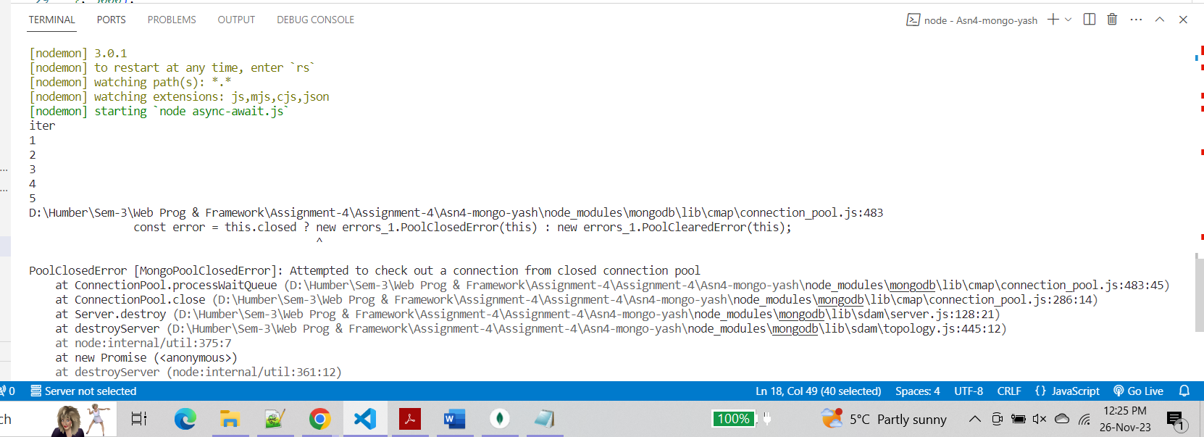

**Step 4 :-**

Bonus: Can you design the given functionality/program using Promise?

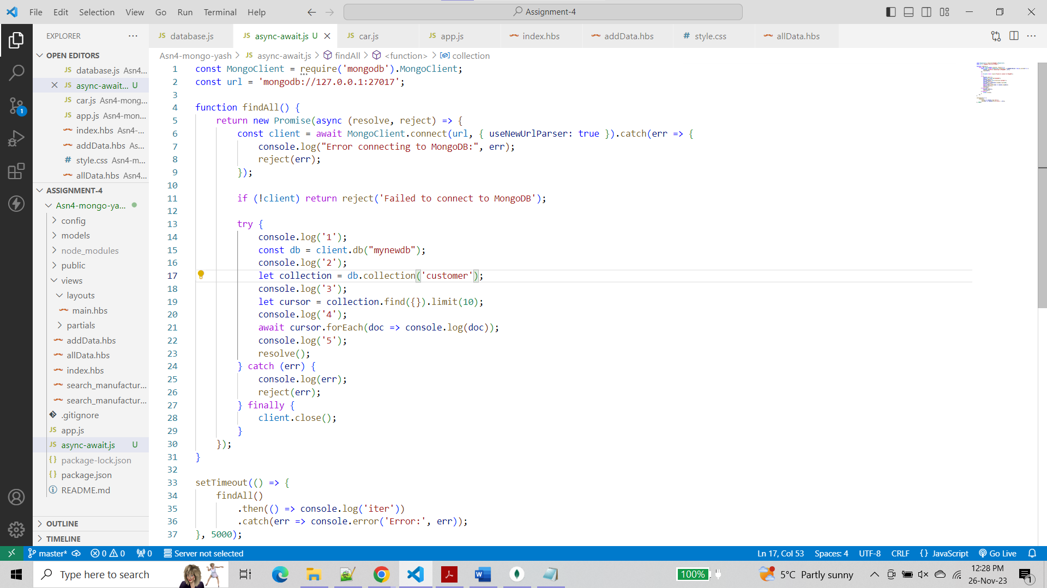

**Output :-**

